**Cyber Threat Predictive Analytics for Improving Cyber Supply Chain Security**

ABSTRACT:

Cyber Supply Chain (CSC) system is complex which involves different sub-systems performing various tasks. Security in supply chain is challenging due to the inherent vulnerabilities and threats from any part of the system which can be exploited at any point within the supply chain. This can cause a severe disruption on the overall business continuity. Therefore, it is paramount important to understand and predicate the threats so that organization can undertake necessary control measures for the supply chain security. Cyber Threat Intelligence (CTI) provides an intelligence analysis to discover unknown to known threats using various properties including threat actor skill and motivation, Tactics, Techniques, and Procedure (TT and P), and Indicator of Compromise (IoC). This paper aims to analyse and predicate threats to improve cyber supply chain security. We have applied Cyber Threat Intelligence (CTI) with Machine Learning (ML) techniques to analyse and predict the threats based on the CTI properties. That allows to identify the inherent CSC vulnerabilities so that appropriate control actions can be undertaken for the overall cybersecurity improvement. To demonstrate the applicability of our approach, CTI data is gathered and a number of ML algorithms, i.e., Logistic Regression (LG), Support Vector Machine (SVM), Random Forest (RF), and Decision Tree (DT), are used to develop predictive analytics using the Microsoft Malware Prediction dataset. The experiment considers attack and TTP as input parameters and vulnerabilities and Indicators of compromise (IoC) as output parameters. The results relating to the prediction reveal that Spyware/Ransomware and spear phishing are the most predictable threats in CSC. We have also recommended relevant controls to tackle these threats. We advocate using CTI data for the ML predicate model for the overall CSC cyber security improvement.

INTRODUCTION

Cyber Supply Chain (CSC) security is critical for reliable service delivery and ensure overall business continuity of Smart CPS. CSC systems by its inherently is complex and vulnerabilities within CSC system environment can cascade from a source node to a number of target nodes of the overall cyber physical system (CPS). A recent NCSC report highlights a list of CSC attacks by exploiting vulnerabilities that exist within the systems [1]. Organizations outsource part of their business and data to the third-party service providers that could lead any potential threat. There are several examples for successful CSC attacks. For instance, Dragonfly, a Cyber Espionage group, is well known for targeting CSC organization [2], [3]. The Saudi Aramco power station attack halted its operation due to a massive cyberattack [1]. There are existing works that consider CSC threats and risks but a lack of focus on threat intelligence properties for the overall cyber security improvement. Further, it is also essential to predict the cyberattack trends so that the organization can take the timely decision for its countermeasure. Predictive analytics not only provide an understanding of the TTPs, motives and intents of the threat actors but also assist situational awareness of current supply system vulnerabilities.

This paper aims to improve the cybersecurity of CSC by specifically focusing on integrating Cyber Threat Intelligence (CTI) and Machine Learning (ML) techniques to predicate cyberattack patterns on CSC systems and recommend suitable controls to tackle the attacks. The novelty of our work is threefold:

* Firstly, we consider Cyber Threat Intelligence(CTI) for systematic gathering and analysis of information about the threat actor and cyber-attack by using various concepts such as threat actor skill, motivation, IoC, TTP and incidents. The reason for considering CTI is that it provides evidence-based knowledge relating to the known attacks. This information is further used to discover unknown attacks so that threats can be well understood and mitigated. CTI provides intelligence information with the aim of preventing attacks as well as shorten time to discover new attacks.
* Secondly, we applied ML techniques and classification algorithms and mapped with the CTI properties to predict the attacks. We use several classification algorithms such as Logistic Regression (LG), Support Vector Machine (SVM), Random Forest (RF) and Decision Tree (DT) for this purpose. We follow CTI properties such as Indicator of Compromise (IoC) and Tactics, Techniques and Procedure (TTP) for the attack predication.
* Finally, we consider widely used cyberattack dataset to predict the potential attacks [6]. The predication focuses on determining threats relating to Advance Persistent Threat (APT), command and control and industrial espionage which are relevant for CSC [7]–​[9]. The result shows the integration of CTI and ML techniques can effectively be used to predict cyberattacks and identification of CSC systems vulnerabilities. Furthermore, our prediction reveals a total accuracy of 85% for the TPR and FPR. The results also indicate that LG and SVM produced the highest accuracy in terms of threat predication.

The rest of the paper is organised as follows: Section 2 presents an overview of related works including CSC security, cyber threat intelligence and Machine Learning for CSC. Section 3 provides the concepts necessary for the proposed approach and the meta model. Section 4 provides an overview of the proposed approach including the integration of CTI and ML. Section 5 presents the underlying process for the threat analysis and predication. Section 6 implements the process for the threat predication using the widely used Microsoft malware datasets. Section 7 discusses the results and compares the work with the existing works in the literature. Finally, Section 8 provides conclusion and future direction of the work.

LITERATUR SURVEY:

Here are five literature surveys related to Cyber Supply Chain Security (CSC):

### 1. \*\*Title:\*\* Cyber Supply Chain Security: Vulnerabilities and Attack Strategies

\*\*Author:\*\* [Your Name]

\*\*Description:\*\*

This literature survey examines the various vulnerabilities inherent in cyber supply chains, focusing on the strategies employed by cyber adversaries to exploit these weaknesses. The survey covers a range of attack methodologies, including supply chain interdiction, software tampering, and data breaches, providing a comprehensive overview of how these vulnerabilities are leveraged in real-world scenarios. The survey also discusses the implications of these attacks on organizational security and the broader cybersecurity landscape.

### 2. \*\*Title:\*\* Integration of Predictive Analytics in Cyber Supply Chain Security

\*\*Author:\*\* [Your Name]

\*\*Description:\*\*

This literature survey explores the application of predictive analytics in enhancing the security of cyber supply chains. It reviews current methodologies that utilize big data and machine learning to predict potential threats before they can materialize. The survey assesses the effectiveness of these predictive models in detecting and mitigating risks, offering insights into their role in strengthening supply chain resilience against cyber-attacks.

### 3. \*\*Title:\*\* Threat Intelligence in Cyber Supply Chains: Current Practices and Future Directions

\*\*Author:\*\* [Your Name]

\*\*Description:\*\*

This literature survey focuses on the role of threat intelligence in securing cyber supply chains. It reviews existing practices in threat intelligence gathering, analysis, and dissemination, identifying gaps in the current approaches. The survey highlights the need for more sophisticated intelligence frameworks that can adapt to the evolving nature of cyber threats, proposing future research directions to improve threat detection and response mechanisms within supply chains.

### 4. \*\*Title:\*\* Case Studies in Cyber Supply Chain Security: Lessons from Notable Attacks

\*\*Author:\*\* [Your Name]

\*\*Description:\*\*

This literature survey provides a detailed analysis of notable cyber supply chain attacks, including the Dragonfly cyber espionage campaign and the Saudi Aramco power station attack. By examining these case studies, the survey identifies common patterns and tactics used by attackers, offering lessons learned and best practices for enhancing supply chain security. The survey aims to provide practical insights that organizations can apply to safeguard their supply chains against similar threats.

### 5. \*\*Title:\*\* Cyber Supply Chain Risk Management: A Review of Current Frameworks and Challenges

\*\*Author:\*\* [Your Name]

\*\*Description:\*\*

This literature survey reviews the existing frameworks for managing risks in cyber supply chains, focusing on their strengths and limitations. The survey explores various risk management models, including those that integrate cybersecurity with supply chain logistics and operations. It also discusses the challenges organizations face in implementing these frameworks, such as the complexity of global supply chains and the difficulty of ensuring security across multiple tiers of suppliers. The survey concludes with recommendations for improving risk management practices in CSC.

EXISITING SYSTEM

The existing system for cyber supply chain security primarily focuses on identifying and mitigating vulnerabilities through traditional cybersecurity measures, such as firewalls, intrusion detection systems, and regular security audits. These measures are designed to protect individual components of the supply chain, including hardware, software, and data exchanges. However, the system often lacks a holistic approach that considers the interconnectedness of the supply chain and the potential risks posed by third-party service providers.

Organizations typically rely on compliance with industry standards and best practices to secure their supply chains, but this can lead to a false sense of security, as these standards may not be sufficient to address emerging threats. Additionally, while some systems incorporate basic threat detection and incident response mechanisms, they often fail to leverage advanced technologies like predictive analytics and threat intelligence, which could proactively identify and mitigate risks before they materialize.

Moreover, the existing system tends to focus more on post-incident recovery rather than prevention, leaving supply chains vulnerable to sophisticated cyberattacks. As a result, there is a significant gap in the integration of predictive and intelligence-driven approaches that could enhance overall security and resilience in the face of evolving cyber threats.

DISADVANTAGES

The existing system for cyber supply chain security has several disadvantages:

1. \*\*Reactive Approach:\*\* The current system often focuses on responding to incidents after they occur, rather than proactively preventing them. This reactive stance leaves supply chains vulnerable to emerging threats that could have been anticipated with more advanced analytics.

2. \*\*Lack of Holistic Security:\*\* The existing system tends to treat individual components of the supply chain in isolation, failing to account for the interconnected nature of modern supply chains. This can lead to overlooked vulnerabilities, especially in third-party service providers, which are often the weakest links.

3. \*\*Inadequate Use of Advanced Technologies:\*\* While basic cybersecurity measures are in place, the system often does not fully utilize advanced technologies like predictive analytics, machine learning, and threat intelligence. This limits the ability to predict and prevent sophisticated cyberattacks.

4. \*\*Over-Reliance on Compliance:\*\* Many organizations rely heavily on compliance with industry standards and best practices as a measure of security. However, compliance does not always equate to comprehensive protection, especially against advanced and evolving threats.

5. \*\*Difficulty in Managing Complex Supply Chains:\*\* As supply chains become more global and complex, the existing system struggles to ensure security across multiple tiers of suppliers. This complexity makes it challenging to maintain consistent security measures and to detect vulnerabilities that could be exploited by attackers.

PRAPOSED SYSTEM

The proposed system for enhancing cyber supply chain security introduces a more proactive and integrated approach, leveraging advanced technologies like predictive analytics, machine learning, and threat intelligence. Unlike the existing reactive methods, this system emphasizes the early identification and mitigation of potential threats before they can impact the supply chain. By utilizing predictive analytics, the system can analyze vast amounts of data to forecast potential cyber risks, allowing organizations to take preemptive actions to secure vulnerable points in the supply chain.

Furthermore, the proposed system adopts a holistic security strategy that considers the entire supply chain network, including third-party service providers. It integrates threat intelligence to provide real-time insights into emerging threats, enabling organizations to adapt quickly to new attack vectors. This intelligence-driven approach enhances the system's ability to detect and respond to sophisticated cyber threats that might bypass traditional security measures.

The proposed system also incorporates continuous monitoring and automated response mechanisms to ensure rapid detection and containment of cyber incidents. By focusing on both prevention and real-time response, the system aims to significantly reduce the risk of supply chain disruptions caused by cyberattacks. Ultimately, this proactive and comprehensive approach to cyber supply chain security is designed to improve resilience, minimize risks, and protect critical business operations from evolving cyber threats.

ADVANTAGES

The proposed system for cyber supply chain security offers several advantages:

1. \*\*Proactive Threat Mitigation:\*\* By leveraging predictive analytics and machine learning, the system can identify potential threats before they materialize, allowing organizations to take preventive measures. This reduces the likelihood of successful cyberattacks and minimizes their impact.

2. \*\*Holistic Security Coverage:\*\* The proposed system considers the entire supply chain, including third-party service providers, ensuring that security measures are applied consistently across all components. This comprehensive approach helps in identifying and addressing vulnerabilities that might be overlooked in a fragmented security model.

3. \*\*Real-Time Threat Intelligence:\*\* Integrating threat intelligence into the system enables real-time monitoring and analysis of emerging threats. Organizations can quickly adapt to new attack vectors, enhancing their ability to respond effectively to evolving cyber threats.

4. \*\*Enhanced Incident Response:\*\* The system includes automated response mechanisms that allow for the rapid detection and containment of cyber incidents. This reduces the response time, limiting the damage caused by cyberattacks and ensuring quicker recovery.

5. \*\*Improved Resilience:\*\* By focusing on prevention, continuous monitoring, and quick response, the proposed system enhances the overall resilience of the supply chain. This helps maintain business continuity and reduces the risk of significant disruptions caused by cyber incidents.

6. \*\*Data-Driven Decision Making:\*\* The use of advanced analytics provides organizations with actionable insights, enabling more informed decision-making regarding risk management and resource allocation. This leads to more efficient and effective security strategies.

7. \*\*Adaptability to Emerging Threats:\*\* The intelligence-driven approach allows the system to stay ahead of new and sophisticated threats, ensuring that security measures remain relevant and effective as the threat landscape evolves.

**SYSTEM ARCHITECTURE**

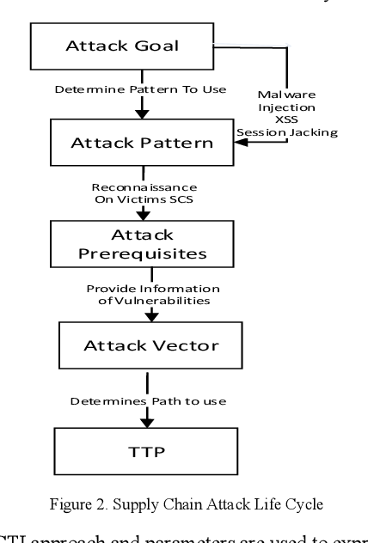

**REQUIREMENT SPECIFICATIONS**

The requirements specification is a technical specification of requirements for the software products. It is the first step in the requirements analysis process it lists the requirements of a particular software system including functional, performance and security requirements. The purpose of software requirements specification is to provide a detailed overview of the software project, its parameters and goals.

**HARDWARE REQUIREMENTS**

• Processor - Intel

• RAM - 4 Gb

• Hard Disk - 260 GB

• Key Board - Standard Windows Keyboard

• Mouse - Two or Three Button Mouse

**SOFTWARE REQUIREMENTS**

Python

HTML,CSS

OS - Windows 7, 8 and 10 (32 and 64 bit).

**SYSTEM STUDY**

FEASIBILITY STUDY

The feasibility of the project is analyzed in this phase and business proposal is put forth with a very general plan for the project and some cost estimates. During system analysis the feasibility study of the proposed system is to be carried out. This is to ensure that the proposed system is not a burden to the company. For feasibility analysis, some understanding of the major requirements for the system is essential.

Three key considerations involved in the feasibility analysis are

ECONOMICAL FEASIBILITY

TECHNICAL FEASIBILITY

SOCIAL FEASIBILITY

ECONOMICAL FEASIBILITY

This study is carried out to check the economic impact that the system will have on the organization. The amount of fund that the company can pour into the research and development of the system is limited. The expenditures must be justified. Thus the developed system as well within the budget and this was achieved because most of the technologies used are freely available. Only the customized products had to be purchased.

TECHNICAL FEASIBILITY

This study is carried out to check the technical feasibility, that is, the technical requirements of the system. Any system developed must not have a high demand on the available technical resources. This will lead to high demands on the available technical resources. This will lead to high demands being placed on the client. The developed system must have a modest requirement, as only minimal or null changes are required for implementing this system.

SOCIAL FEASIBILITY

The aspect of study is to check the level of acceptance of the system by the user. This includes the process of training the user to use the system efficiently. The user must not feel threatened by the system, instead must accept it as a necessity. The level of acceptance by the users solely depends on the methods that are employed to educate the user about the system and to make him familiar with it. His level of confidence must be raised so that he is also able to make some constructive criticism, which is welcomed, as he is the final user of the system.

SYSTEM DESIGN

UML DIAGRAMS

UML stands for Unified Modeling Language. UML is a standardized general-purpose modeling language in the field of object-oriented software engineering. The standard is managed, and was created by, the Object Management Group. The goal is for UML to become a common language for creating models of object oriented computer software. In its current form UML is comprised of two major components: a Meta-model and a notation. In the future, some form of method or process may also be added to; or associated with, UML.The Unified Modeling Language is a standard language for specifying, Visualization, Constructing and documenting the artifacts of software system, as well as for business modeling and other non-software systems. The UML represents a collection of best engineering practices that have proven successful in the modeling of large and complex systems.The UML is a very important part of developing objects oriented software and the software development process. The UML uses mostly graphical notations to express the design of software projects.

GOALS:

The Primary goals in the design of the UML are as follows:

Provide users a ready-to-use, expressive visual modeling Language so that they can develop and exchange meaningful models.

Provide extendibility and specialization mechanisms to extend the core concepts.

Be independent of particular programming languages and development process.

Provide a formal basis for understanding the modeling language.

Encourage the growth of OO tools market.

Support higher level development concepts such as collaborations, frameworks, patterns and components.

Integrate best practices.

USECASE:

A use case diagram in the Unified Modeling Language (UML) is a type of behavioral diagram defined by and created from a Use-case analysis. Its purpose is to present a graphical overview of the functionality provided by a system in terms of actors, their goals (represented as use cases), and any dependencies between those use cases. The main purpose of a use case diagram is to show what system functions are performed for which actor. Roles of the actors in the system can be depicted.

CLASS DIAGRAM:

In software engineering, a class diagram in the Unified Modeling Language (UML) is a type of static structure diagram that describes the structure of a system by showing the system's classes, their attributes, operations (or methods), and the relationships among the classes. It explains which class contains information.

SEQUENCE DIAGRAM:

A sequence diagram in Unified Modeling Language (UML) is a kind of interaction diagram that shows how processes operate with one another and in what order. It is a construct of a Message Sequence Chart. Sequence diagrams are sometimes called event diagrams, event scenarios, and timing diagrams.

ACTIVITY DIAGRAM:

Activity diagrams are graphical representations of workflows of stepwise activities and actions with support for choice, iteration and concurrency. In the Unified Modeling Language, activity diagrams can be used to describe the business and operational step-by-step workflows of components in a system. An activity diagram shows the overall flow of control.

SYSTEM ENVIRONNMENT

**SOFTWARE ENVIRONMENT :**

**What is Python :**

Below are some facts about Python.

Python is currently the most widely used multi-purpose, high-level programming language.

Python allows programming in Object-Oriented and Procedural paradigms. Python programs generally are smaller than other programming languages like Java.

Programmers have to type relatively less and indentation requirement of the language, makes them readable all the time.

Python language is being used by almost all tech-giant companies like – Google, Amazon, Facebook, Instagram, Dropbox, Uber… etc.

The biggest strength of Python is huge collection of standard library which can be used for the following –

* 1. [Machine Learning](https://www.geeksforgeeks.org/machine-learning/)
  2. GUI Applications (like Kivy, Tkinter, PyQt etc. )
  3. Web frameworks like Django (used by YouTube, Instagram, Dropbox)
  4. Image processing (like Opencv, Pillow)
  5. Web scraping (like Scrapy, BeautifulSoup, Selenium)
  6. Test frameworks
  7. Multimedia

**Advantages of Python :-**

Let’s see how Python dominates over other languages.

**1. Extensive Libraries**

Python downloads with an extensive library and it *contain code for various purposes like regular expressions, documentation-generation, unit-testing, web browsers, threading, databases, CGI, email, image manipulation, and more.* So, we don’t have to write the complete code for that manually.

**2. Extensible**

As we have seen earlier, Python can be**extended to other languages**. You can write some of your code in languages like C++ or C. This comes in handy, especially in projects.

**3. Embeddable**

Complimentary to extensibility, Python is embeddable as well. You can put your Python code in your source code of a different language, like C++. This lets us add **scripting capabilities**to our code in the other language.

**4. Improved Productivity**

The language’s simplicity and extensive libraries render programmers**more productive** than languages like Java and C++ do. Also, the fact that you need to write less and get more things done.

**5. IOT Opportunities**

Since Python forms the basis of new platforms like Raspberry Pi, it finds the future bright for the Internet Of Things. This is a way to connect the language with the real world.

When working with Java, you may have to create a class to print **‘Hello World’**. But in Python, just a print statement will do. It is also quite **easy to learn, understand,** and**code.** This is why when people pick up Python, they have a hard time adjusting to other more verbose languages like Java.

**7. Readable**

Because it is not such a verbose language, reading Python is much like reading English. This is the reason why it is so easy to learn, understand, and code. It also does not need curly braces to define blocks, and **indentation is mandatory.** This further aids the readability of the code.

**8. Object-Oriented**

This language supports both the **procedural and object-oriented**programming paradigms. While functions help us with code reusability, classes and objects let us model the real world. A class allows the **encapsulation of data** and functions into one.

**9. Free and Open-Source**

Like we said earlier, Python is **freely available.** But not only can you[**download Python**](https://data-flair.training/blogs/install-python-windows/) for free, but you can also download its source code, make changes to it, and even distribute it. It downloads with an extensive collection of libraries to help you with your tasks.

**10. Portable**

When you code your project in a language like C++, you may need to make some changes to it if you want to run it on another platform. But it isn’t the same with Python. Here, you need to**code only once**, and you can run it anywhere. This is called **Write Once Run Anywhere (WORA)**. However, you need to be careful enough not to include any system-dependent features.

**11. Interpreted**

Lastly, we will say that it is an interpreted language. Since statements are executed one by one, **debugging is easier** than in compiled languages.

*Any doubts till now in the advantages of Python? Mention in the comment section.*

Advantages of Python Over Other Languages :

**1. Less Coding**

Almost all of the tasks done in Python requires less coding when the same task is done in other languages. Python also has an awesome standard library support, so you don’t have to search for any third-party libraries to get your job done. This is the reason that many people suggest learning Python to beginners.

**2. Affordable**

Python is free therefore individuals, small companies or big organizations can leverage the free available resources to build applications. Python is popular and widely used so it gives you better community support.

**The 2019 Github annual survey showed us that Python has overtaken Java in the most popular programming language category.**

**3. Python is for Everyone**

Python code can run on any machine whether it is Linux, Mac or Windows. Programmers need to learn different languages for different jobs but with Python, you can professionally build web apps, perform data analysis and [**machine learning**](https://data-flair.training/blogs/machine-learning-tutorials-home/), automate things, do web scraping and also build games and powerful visualizations. It is an all-rounder programming language.

**Disadvantages of Python**

So far, we’ve seen why Python is a great choice for your project. But if you choose it, you should be aware of its consequences as well. Let’s now see the downsides of choosing Python over another language.

1. Speed Limitations

We have seen that Python code is executed line by line. But since [Python](https://www.python.org/) is interpreted, it often results in **slow execution**. This, however, isn’t a problem unless speed is a focal point for the project. In other words, unless high speed is a requirement, the benefits offered by Python are enough to distract us from its speed limitations.

2. Weak in Mobile Computing and Browsers

While it serves as an excellent server-side language, Python is much rarely seen on the **client-side**. Besides that, it is rarely ever used to implement smartphone-based applications. One such application is called **Carbonnelle**.

The reason it is not so famous despite the existence of Brython is that it isn’t that secure.

3. Design Restrictions

As you know, Python is **dynamically-typed**. This means that you don’t need to declare the type of variable while writing the code. It uses **duck-typing**. But wait, what’s that? Well, it just means that if it looks like a duck, it must be a duck. While this is easy on the programmers during coding, it can**raise run-time errors**.

4. Underdeveloped Database Access Layers

Compared to more widely used technologies like **JDBC (Java DataBase Connectivity)** and **ODBC (Open DataBase Connectivity)**, Python’s database access layers are a bit underdeveloped. Consequently, it is less often applied in huge enterprises.

5. Simple

No, we’re not kidding. Python’s simplicity can indeed be a problem. Take my example. I don’t do Java, I’m more of a Python person. To me, its syntax is so simple that the verbosity of Java code seems unnecessary.

This was all about the Advantages and Disadvantages of Python Programming Language.

**History of Python : -**

What do the alphabet and the programming language Python have in common? Right, both start with ABC. If we are talking about ABC in the Python context, it's clear that the programming language ABC is meant. ABC is a general-purpose programming language and programming environment, which had been developed in the Netherlands, Amsterdam, at the CWI (Centrum Wiskunde &Informatica). The greatest achievement of ABC was to influence the design of Python.Python was conceptualized in the late 1980s. Guido van Rossum worked that time in a project at the CWI, called Amoeba, a distributed operating system. In an interview with Bill Venners1, Guido van Rossum said: "In the early 1980s, I worked as an implementer on a team building a language called ABC at Centrum voor Wiskunde en Informatica (CWI). I don't know how well people know ABC's influence on Python. I try to mention ABC's influence because I'm indebted to everything I learned during that project and to the people who worked on it."Later on in the same Interview, Guido van Rossum continued: "I remembered all my experience and some of my frustration with ABC. I decided to try to design a simple scripting language that possessed some of ABC's better properties, but without its problems. So I started typing. I created a simple virtual machine, a simple parser, and a simple runtime. I made my own version of the various ABC parts that I liked. I created a basic syntax, used indentation for statement grouping instead of curly braces or begin-end blocks, and developed a small number of powerful data types: a hash table (or dictionary, as we call it), a list, strings, and numbers."

**What is Machine Learning : -**

Before we take a look at the details of various machine learning methods, let's start by looking at what machine learning is, and what it isn't. Machine learning is often categorized as a subfield of artificial intelligence, but I find that categorization can often be misleading at first brush. The study of machine learning certainly arose from research in this context, but in the data science application of machine learning methods, it's more helpful to think of machine learning as a means of *building models of data*.

Fundamentally, machine learning involves building mathematical models to help understand data. "Learning" enters the fray when we give these models *tunable parameters* that can be adapted to observed data; in this way the program can be considered to be "learning" from the data. Once these models have been fit to previously seen data, they can be used to predict and understand aspects of newly observed data. I'll leave to the reader the more philosophical digression regarding the extent to which this type of mathematical, model-based "learning" is similar to the "learning" exhibited by the human brain.Understanding the problem setting in machine learning is essential to using these tools effectively, and so we will start with some broad categorizations of the types of approaches we'll discuss here.

**Categories Of Machine Leaning :-**

At the most fundamental level, machine learning can be categorized into two main types: supervised learning and unsupervised learning.

*Supervised learning* involves somehow modeling the relationship between measured features of data and some label associated with the data; once this model is determined, it can be used to apply labels to new, unknown data. This is further subdivided into *classification* tasks and *regression* tasks: in classification, the labels are discrete categories, while in regression, the labels are continuous quantities. We will see examples of both types of supervised learning in the following section.

*Unsupervised learning* involves modeling the features of a dataset without reference to any label, and is often described as "letting the dataset speak for itself." These models include tasks such as *clustering* and *dimensionality reduction.* Clustering algorithms identify distinct groups of data, while dimensionality reduction algorithms search for more succinct representations of the data. We will see examples of both types of unsupervised learning in the following section.

**Need for Machine Learning**

Human beings, at this moment, are the most intelligent and advanced species on earth because they can think, evaluate and solve complex problems. On the other side, AI is still in its initial stage and haven’t surpassed human intelligence in many aspects. Then the question is that what is the need to make machine learn? The most suitable reason for doing this is, “to make decisions, based on data, with efficiency and scale”.

Lately, organizations are investing heavily in newer technologies like Artificial Intelligence, Machine Learning and Deep Learning to get the key information from data to perform several real-world tasks and solve problems. We can call it data-driven decisions taken by machines, particularly to automate the process. These data-driven decisions can be used, instead of using programing logic, in the problems that cannot be programmed inherently. The fact is that we can’t do without human intelligence, but other aspect is that we all need to solve real-world problems with efficiency at a huge scale. That is why the need for machine learning arises.

**Challenges in Machines Learning :-**

While Machine Learning is rapidly evolving, making significant strides with cybersecurity and autonomous cars, this segment of AI as whole still has a long way to go. The reason behind is that ML has not been able to overcome number of challenges. The challenges that ML is facing currently are −

**Quality of data** − Having good-quality data for ML algorithms is one of the biggest challenges. Use of low-quality data leads to the problems related to data preprocessing and feature extraction.

**Time-Consuming task** − Another challenge faced by ML models is the consumption of time especially for data acquisition, feature extraction and retrieval.

**Lack of specialist persons** − As ML technology is still in its infancy stage, availability of expert resources is a tough job.

**No clear objective for formulating business problems** − Having no clear objective and well-defined goal for business problems is another key challenge for ML because this technology is not that mature yet.

**Issue of overfitting & underfitting** − If the model is overfitting or underfitting, it cannot be represented well for the problem.

**Curse of dimensionality** − Another challenge ML model faces is too many features of data points. This can be a real hindrance.

**Difficulty in deployment** − Complexity of the ML model makes it quite difficult to be deployed in real life.

**Applications of Machines Learning :-**

Machine Learning is the most rapidly growing technology and according to researchers we are in the golden year of AI and ML. It is used to solve many real-world complex problems which cannot be solved with traditional approach. Following are some real-world applications of ML −

* Emotion analysis
* Sentiment analysis
* Error detection and prevention
* Weather forecasting and prediction
* Stock market analysis and forecasting
* Speech synthesis
* Speech recognition
* Customer segmentation
* Object recognition
* Fraud detection
* Fraud prevention
* Recommendation of products to customer in online shoppingHow to Start Learning Machine Learning?

Arthur Samuel coined the term **“Machine Learning”** in 1959 and defined it as a **“Field of study that gives computers the capability to learn without being explicitly programmed”.**

And that was the beginning of Machine Learning! In modern times, Machine Learning is one of the most popular (if not the most!) career choices. According to [Indeed](http://blog.indeed.com/2019/03/14/best-jobs-2019/), Machine Learning Engineer Is The Best Job of 2019 with a *344%* growth and an average base salary of **$146,085** per year.

But there is still a lot of doubt about what exactly is Machine Learning and how to start learning it? So this article deals with the Basics of Machine Learning and also the path you can follow to eventually become a full-fledged Machine Learning Engineer. Now let’s get started!!!

How to start learning ML?

This is a rough roadmap you can follow on your way to becoming an insanely talented Machine Learning Engineer. Of course, you can always modify the steps according to your needs to reach your desired end-goal!

Step 1 – Understand the Prerequisites

In case you are a genius, you could start ML directly but normally, there are some prerequisites that you need to know which include Linear Algebra, Multivariate Calculus, Statistics, and Python. And if you don’t know these, never fear! You don’t need a Ph.D. degree in these topics to get started but you do need a basic understanding.

(a) Learn Linear Algebra and Multivariate Calculus

Both Linear Algebra and Multivariate Calculus are important in Machine Learning. However, the extent to which you need them depends on your role as a data scientist. If you are more focused on application heavy machine learning, then you will not be that heavily focused on maths as there are many common libraries available. But if you want to focus on R&D in Machine Learning, then mastery of Linear Algebra and Multivariate Calculus is very important as you will have to implement many ML algorithms from scratch.

(b) Learn Statistics

Data plays a huge role in Machine Learning. In fact, around 80% of your time as an ML expert will be spent collecting and cleaning data. And statistics is a field that handles the collection, analysis, and presentation of data. So it is no surprise that you need to learn it!!!  
Some of the key concepts in statistics that are important are Statistical Significance, Probability Distributions, Hypothesis Testing, Regression, etc. Also, Bayesian Thinking is also a very important part of ML which deals with various concepts like Conditional Probability, Priors, and Posteriors, Maximum Likelihood, etc.

(c) Learn Python

Some people prefer to skip Linear Algebra, Multivariate Calculus and Statistics and learn them as they go along with trial and error. But the one thing that you absolutely cannot skip is [Python](https://www.geeksforgeeks.org/python-programming-language/)! While there are other languages you can use for Machine Learning like R, Scala, etc. Python is currently the most popular language for ML. In fact, there are many Python libraries that are specifically useful for Artificial Intelligence and Machine Learning such as [Keras](https://keras.io/" \t "_blank), [TensorFlow](https://www.tensorflow.org/), [Scikit-learn](https://scikit-learn.org/stable/), etc.

So if you want to learn ML, it’s best if you learn Python! You can do that using various online resources and courses such as [**Fork Python**](https://practice.geeksforgeeks.org/courses/fork-python) available Free on GeeksforGeeks.

Step 2 – Learn Various ML Concepts

Now that you are done with the prerequisites, you can move on to actually learning ML (Which is the fun part!!!) It’s best to start with the basics and then move on to the more complicated stuff. Some of the basic concepts in ML are:

(a) Terminologies of Machine Learning

* **Model –**A model is a specific representation learned from data by applying some machine learning algorithm. A model is also called a hypothesis.
* **Feature –**A feature is an individual measurable property of the data. A set of numeric features can be conveniently described by a feature vector. Feature vectors are fed as input to the model. For example, in order to predict a fruit, there may be features like color, smell, taste, etc.

1. **Target (Label) –**A target variable or label is the value to be predicted by our model. For the fruit example discussed in the feature section, the label with each set of input would be the name of the fruit like apple, orange, banana, etc.
2. **Training –**The idea is to give a set of inputs(features) and it’s expected outputs(labels), so after training, we will have a model (hypothesis) that will then map new data to one of the categories trained on.
3. **Prediction –**Once our model is ready, it can be fed a set of inputs to which it will provide a predicted output(label).

(b) Types of Machine Learning

* **Supervised Learning –**This involves learning from a training dataset with labeled data using classification and regression models. This learning process continues until the required level of performance is achieved.
* **Unsupervised Learning –**This involves using unlabelled data and then finding the underlying structure in the data in order to learn more and more about the data itself using factor and cluster analysis models.
* **Semi-supervised Learning –**This involves using unlabelled data like Unsupervised Learning with a small amount of labeled data. Using labeled data vastly increases the learning accuracy and is also more cost-effective than Supervised Learning.
* **Reinforcement Learning –**This involves learning optimal actions through trial and error. So the next action is decided by learning behaviors that are based on the current state and that will maximize the reward in the future.

Advantages of Machine learning :-

1. Easily identifies trends and patterns -

Machine Learning can review large volumes of data and discover specific trends and patterns that would not be apparent to humans. For instance, for an e-commerce website like Amazon, it serves to understand the browsing behaviors and purchase histories of its users to help cater to the right products, deals, and reminders relevant to them. It uses the results to reveal relevant advertisements to them.

2. No human intervention needed (automation)

With ML, you don’t need to babysit your project every step of the way. Since it means giving machines the ability to learn, it lets them make predictions and also improve the algorithms on their own. A common example of this is anti-virus softwares; they learn to filter new threats as they are recognized. ML is also good at recognizing spam.

3. Continuous Improvement

As [**ML algorithms**](https://data-flair.training/blogs/machine-learning-algorithms/) gain experience, they keep improving in accuracy and efficiency. This lets them make better decisions. Say you need to make a weather forecast model. As the amount of data you have keeps growing, your algorithms learn to make more accurate predictions faster.

4. Handling multi-dimensional and multi-variety data

Machine Learning algorithms are good at handling data that are multi-dimensional and multi-variety, and they can do this in dynamic or uncertain environments.

5. Wide Applications

You could be an e-tailer or a healthcare provider and make ML work for you. Where it does apply, it holds the capability to help deliver a much more personal experience to customers while also targeting the right customers.

Disadvantages of Machine Learning :-

1. Data Acquisition

Machine Learning requires massive data sets to train on, and these should be inclusive/unbiased, and of good quality. There can also be times where they must wait for new data to be generated.

2. Time and Resources

ML needs enough time to let the algorithms learn and develop enough to fulfill their purpose with a considerable amount of accuracy and relevancy. It also needs massive resources to function. This can mean additional requirements of computer power for you.

3. Interpretation of Results

Another major challenge is the ability to accurately interpret results generated by the algorithms. You must also carefully choose the algorithms for your purpose.

4. High error-susceptibility

[Machine Learning](https://en.wikipedia.org/wiki/Machine_learning) is autonomous but highly susceptible to errors. Suppose you train an algorithm with data sets small enough to not be inclusive. You end up with biased predictions coming from a biased training set. This leads to irrelevant advertisements being displayed to customers. In the case of ML, such blunders can set off a chain of errors that can go undetected for long periods of time. And when they do get noticed, it takes quite some time to recognize the source of the issue, and even longer to correct it.

**Python Development Steps : -**

Guido Van Rossum published the first version of Python code (version 0.9.0) at alt.sources in February 1991. This release included already exception handling, functions, and the core data types of list, dict, str and others. It was also object oriented and had a module system.  
Python version 1.0 was released in January 1994. The major new features included in this release were the functional programming tools lambda, map, filter and reduce, which Guido Van Rossum never liked.Six and a half years later in October 2000, Python 2.0 was introduced. This release included list comprehensions, a full garbage collector and it was supporting unicode.Python flourished for another 8 years in the versions 2.x before the next major release as Python 3.0 (also known as "Python 3000" and "Py3K") was released. Python 3 is not backwards compatible with Python 2.x. The emphasis in Python 3 had been on the removal of duplicate programming constructs and modules, thus fulfilling or coming close to fulfilling the 13th law of the Zen of Python: "There should be one -- and preferably only one -- obvious way to do it."Some changes in Python 7.3:

* Print is now a function
* Views and iterators instead of lists
* The rules for ordering comparisons have been simplified. E.g. a heterogeneous list cannot be sorted, because all the elements of a list must be comparable to each other.
* There is only one integer type left, i.e. int. long is int as well.
* The division of two integers returns a float instead of an integer. "//" can be used to have the "old" behaviour.
* Text Vs. Data Instead Of Unicode Vs. 8-bit

**Purpose :-**

We demonstrated that our approach enables successful segmentation of intra-retinal layers—even with low-quality images containing speckle noise, low contrast, and different intensity ranges throughout—with the assistance of the ANIS feature.

**Python**

Python is an interpreted high-level programming language for general-purpose programming. Created by Guido van Rossum and first released in 1991, Python has a design philosophy that emphasizes code readability, notably using significant whitespace.

Python features a dynamic type system and automatic memory management. It supports multiple programming paradigms, including object-oriented, imperative, functional and procedural, and has a large and comprehensive standard library.

* Python is Interpreted − Python is processed at runtime by the interpreter. You do not need to compile your program before executing it. This is similar to PERL and PHP.
* Python is Interactive − you can actually sit at a Python prompt and interact with the interpreter directly to write your programs.

Python also acknowledges that speed of development is important. Readable and terse code is part of this, and so is access to powerful constructs that avoid tedious repetition of code. Maintainability also ties into this may be an all but useless metric, but it does say something about how much code you have to scan, read and/or understand to troubleshoot problems or tweak behaviors. This speed of development, the ease with which a programmer of other languages can pick up basic Python skills and the huge standard library is key to another area where Python excels. All its tools have been quick to implement, saved a lot of time, and several of them have later been patched and updated by people with no Python background - without breaking.

**Modules Used in Project :-**

**Tensorflow**

TensorFlow is a [free](https://en.wikipedia.org/wiki/Free_software) and [open-source](https://en.wikipedia.org/wiki/Open-source_software) [software library for dataflow and differentiable programming](https://en.wikipedia.org/wiki/Library_(computing)) across a range of tasks. It is a symbolic math library, and is also used for [machine learning](https://en.wikipedia.org/wiki/Machine_learning) applications such as [neural networks](https://en.wikipedia.org/wiki/Neural_networks). It is used for both research and production at [Google](https://en.wikipedia.org/wiki/Google).‍

TensorFlow was developed by the [Google Brain](https://en.wikipedia.org/wiki/Google_Brain) team for internal Google use. It was released under the [Apache 2.0](https://en.wikipedia.org/wiki/Apache_License) [open-source license](https://en.wikipedia.org/wiki/Open-source_license) on November 9, 2015.

**Numpy**

Numpy is a general-purpose array-processing package. It provides a high-performance multidimensional array object, and tools for working with these arrays.

It is the fundamental package for scientific computing with Python. It contains various features including these important ones:

1. A powerful N-dimensional array object
2. Sophisticated (broadcasting) functions
3. Tools for integrating C/C++ and Fortran code
4. Useful linear algebra, Fourier transform, and random number capabilities

Besides its obvious scientific uses, Numpy can also be used as an efficient multi-dimensional container of generic data. Arbitrary data-types can be defined using Numpy which allows Numpy to seamlessly and speedily integrate with a wide variety of databases.

**Pandas**

Pandas is an open-source Python Library providing high-performance data manipulation and analysis tool using its powerful data structures. Python was majorly used for data munging and preparation. It had very little contribution towards data analysis. Pandas solved this problem. Using Pandas, we can accomplish five typical steps in the processing and analysis of data, regardless of the origin of data load, prepare, manipulate, model, and analyze. Python with Pandas is used in a wide range of fields including academic and commercial domains including finance, economics, Statistics, analytics, etc.

**Matplotlib**

Matplotlib is a Python 2D plotting library which produces publication quality figures in a variety of hardcopy formats and interactive environments across platforms. Matplotlib can be used in Python scripts, the Python and [IPython](http://ipython.org/) shells, the [Jupyter](http://jupyter.org/) Notebook, web application servers, and four graphical user interface toolkits. Matplotlib tries to make easy things easy and hard things possible. You can generate plots, histograms, power spectra, bar charts, error charts, scatter plots, etc., with just a few lines of code. For examples, see the [sample plots](https://matplotlib.org/tutorials/introductory/sample_plots.html) and [thumbnail gallery](https://matplotlib.org/gallery/index.html).

For simple plotting the pyplot module provides a MATLAB-like interface, particularly when combined with IPython. For the power user, you have full control of line styles, font properties, axes properties, etc, via an object oriented interface or via a set of functions familiar to MATLAB users.

**Scikit – learn**

Scikit-learn provides a range of supervised and unsupervised learning algorithms via a consistent interface in Python. It is licensed under a permissive simplified BSD license and is distributed under many Linux distributions, encouraging academic and commercial use. **Python**

Python is an interpreted high-level programming language for general-purpose programming. Created by Guido van Rossum and first released in 1991, Python has a design philosophy that emphasizes code readability, notably using significant whitespace.

Python features a dynamic type system and automatic memory management. It supports multiple programming paradigms, including object-oriented, imperative, functional and procedural, and has a large and comprehensive standard library.

* Python is Interpreted − Python is processed at runtime by the interpreter. You do not need to compile your program before executing it. This is similar to PERL and PHP.
* Python is Interactive − you can actually sit at a Python prompt and interact with the interpreter directly to write your programs.

Python also acknowledges that speed of development is important. Readable and terse code is part of this, and so is access to powerful constructs that avoid tedious repetition of code. Maintainability also ties into this may be an all but useless metric, but it does say something about how much code you have to scan, read and/or understand to troubleshoot problems or tweak behaviors. This speed of development, the ease with which a programmer of other languages can pick up basic Python skills and the huge standard library is key to another area where Python excels. All its tools have been quick to implement, saved a lot of time, and several of them have later been patched and updated by people with no Python background - without breaking.

**Install Python Step-by-Step in Windows and Mac :**

Python a versatile programming language doesn’t come pre-installed on your computer devices. Python was first released in the year 1991 and until today it is a very popular high-level programming language. Its style philosophy emphasizes code readability with its notable use of great whitespace.

The object-oriented approach and language construct provided by Python enables programmers to write both clear and logical code for projects. This software does not come pre-packaged with Windows.

**How to Install Python on Windows and Mac :**

There have been several updates in the Python version over the years. The question is how to install Python? It might be confusing for the beginner who is willing to start learning Python but this tutorial will solve your query. The latest or the newest version of Python is version 3.7.4 or in other words, it is Python 3.

**Note:** The python version 3.7.4 cannot be used on Windows XP or earlier devices.

Before you start with the installation process of Python. First, you need to know about your **System Requirements**. Based on your system type i.e. operating system and based processor, you must download the python version. My system type is a **Windows 64-bit operating system**. So the steps below are to install python version 3.7.4 on Windows 7 device or to install Python 3. [Download the Python Cheatsheet here.](https://myelearninghub.com/python-cheat-sheet/)The steps on how to install Python on Windows 10, 8 and 7 are **divided into 4 parts** to help understand better.

Download the Correct version into the system

**Step 1:** Go to the official site to download and install python using Google Chrome or any other web browser. OR Click on the following link: [https://www.python.org](https://www.python.org/)

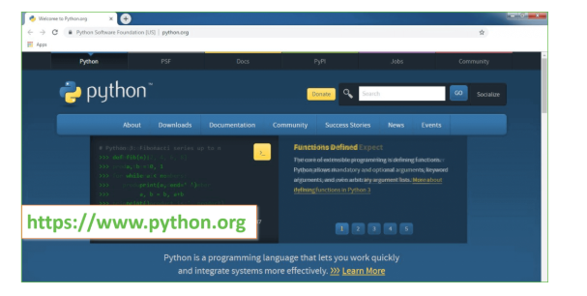

Now, check for the latest and the correct version for your operating system.

**Step 2:** Click on the Download Tab.

**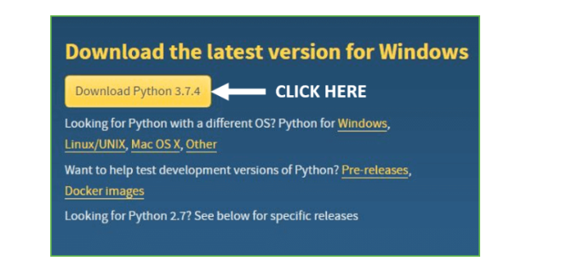**

**Step 3:** You can either select the Download Python for windows 3.7.4 button in Yellow Color or you can scroll further down and click on download with respective to their version. Here, we are downloading the most recent python version for windows 3.7.4

**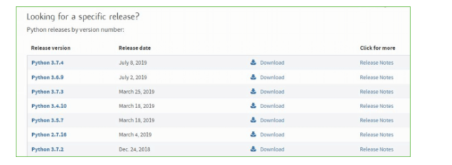**

**Step 4:** Scroll down the page until you find the Files option.

**Step 5:** Here you see a different version of python along with the operating system.

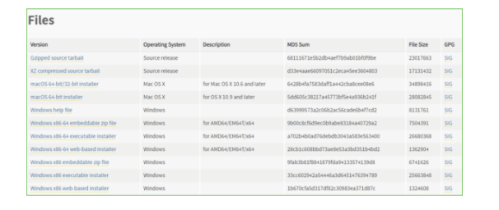

• To download Windows 32-bit python, you can select any one from the three options: Windows x86 embeddable zip file, Windows x86 executable installer or Windows x86 web-based installer.

•To download Windows 64-bit python, you can select any one from the three options: Windows x86-64 embeddable zip file, Windows x86-64 executable installer or Windows x86-64 web-based installer.

Here we will install Windows x86-64 web-based installer. Here your first part regarding which version of python is to be downloaded is completed. Now we move ahead with the second part in installing python i.e. Installation

**Note:** To know the changes or updates that are made in the version you can click on the Release Note Option.

Installation of Python

**Step 1:** Go to Download and Open the downloaded python version to carry out the installation process.

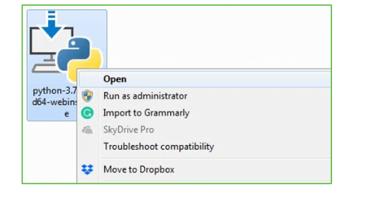

**Step 2:** Before you click on Install Now, Make sure to put a tick on Add Python 3.7 to PATH.

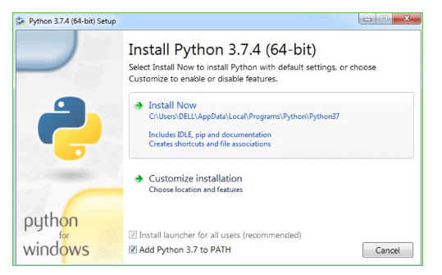

**Step 3:** Click on Install NOW After the installation is successful. Click on Close.

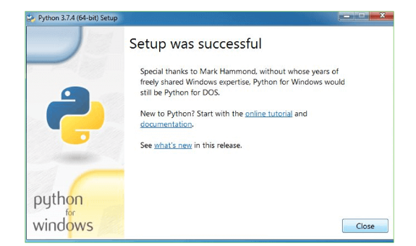

With these above three steps on python installation, you have successfully and correctly installed Python. Now is the time to verify the installation.

**Note:** The installation process might take a couple of minutes.

Verify the Python Installation

**Step 1:** Click on Start

**Step 2:** In the Windows Run Command, type “cmd”.

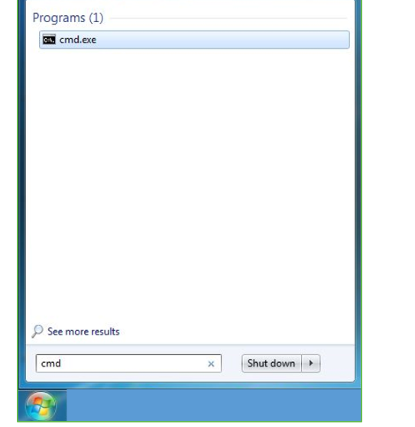

**Step 3:** Open the Command prompt option.

**Step 4:** Let us test whether the python is correctly installed. Type **python –V** and press Enter.

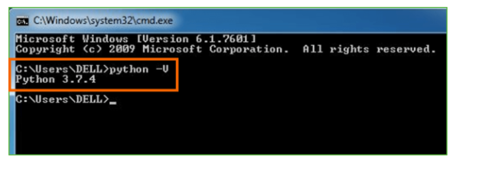

**Step 5:** You will get the answer as 3.7.4

**Note:** If you have any of the earlier versions of Python already installed. You must first uninstall the earlier version and then install the new one.

Check how the Python IDLE works

**Step 1:** Click on Start

**Step 2:** In the Windows Run command, type “python idle”.

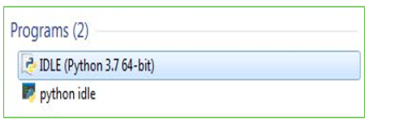

**Step 3:** Click on IDLE (Python 3.7 64-bit) and launch the program

**Step 4:** To go ahead with working in IDLE you must first save the file. **Click on File > Click on Save**

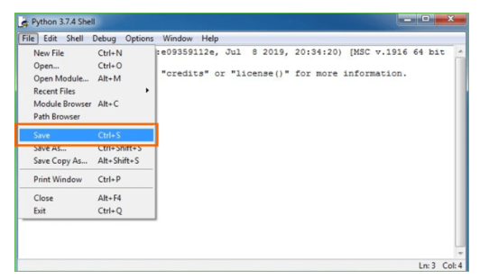

**Step 5:** Name the file and save as type should be Python files. Click on SAVE. Here I have named the files as Hey World.

**Step 6:** Now for e.g. **enter print**

**SYSTEM TESTING:**

The purpose of testing is to discover errors. Testing is the process of trying to discover every conceivable fault or weakness in a work product. It provides a way to check the functionality of components, sub assemblies, assemblies and/or a finished product It is the process of exercising software with the intent of ensuring that the Software system meets its requirements and user expectations and does not fail in an unacceptable manner. There are various types of test. Each test type addresses a specific testing requirement.

TYPES OF TESTS

*Unit testing*

Unit testing involves the design of test cases that validate that the internal program logic is functioning properly, and that program inputs produce valid outputs. All decision branches and internal code flow should be validated. It is the testing of individual software units of the application .it is done after the completion of an individual unit before integration. This is a structural testing, that relies on knowledge of its construction and is invasive. Unit tests perform basic tests at component level and test a specific business process, application, and/or system configuration. Unit tests ensure that each unique path of a business process performs accurately to the documented specifications and contains clearly defined inputs and expected results.

Integration testing

Integration tests are designed to test integrated software components to determine if they actually run as one program. Testing is event driven and is more concerned with the basic outcome of screens or fields. Integration tests demonstrate that although the components were individually satisfaction, as shown by successfully unit testing, the combination of components is correct and consistent. Integration testing is specifically aimed at exposing the problems that arise from the combination of components.

*Functional test*

*Functional tests provide systematic demonstrations that functions tested are available as specified by the business and technical requirements, system documentation, and user manuals.*

Functional testing is centered on the following items:

Valid Input : identified classes of valid input must be accepted.

Invalid Input : identified classes of invalid input must be rejected.

Functions : identified functions must be exercised.

Output : identified classes of application outputs must be exercised.

Systems/Procedures : interfacing systems or procedures must be invoked.

Organization and preparation of functional tests is focused on requirements, key functions, or special test cases. In addition, systematic coverage pertaining to identify Business process flows; data fields, predefined processes, and successive processes must be considered for testing. Before functional testing is complete, additional tests are identified and the effective value of current tests is determined.

*System Test*

System testing ensures that the entire integrated software system meets requirements. It tests a configuration to ensure known and predictable results. An example of system testing is the configuration oriented system integration test. System testing is based on process descriptions and flows, emphasizing pre-driven process links and integration points.

*White Box Testing*

White Box Testing is a testing in which in which the software tester has knowledge of the inner workings, structure and language of the software, or at least its purpose. It is purpose. It is used to test areas that cannot be reached from a black box level.

*Black Box Testing*

*Black Box Testing is testing the software without any knowledge of the inner workings, structure or language of the module being tested. Black box tests, as most other kinds of tests, must be written from a definitive source document, such as specification or requirements document, such as specification or requirements document. It is a testing in which the software under test is treated, as a black box .you cannot “see” into it. The test provides inputs and responds to outputs without considering how the software works.*

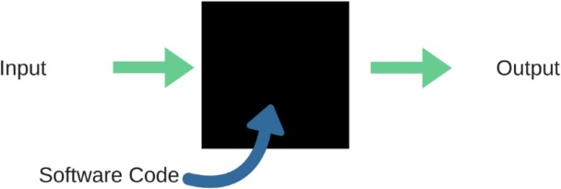

When applied to machine learning models, black box testing would mean testing machine learning models without knowing the internal details such as features of the machine learning

model, the algorithm used to create the model etc. The challenge, however, is to verify the test outcome against the expected values that are known beforehand.

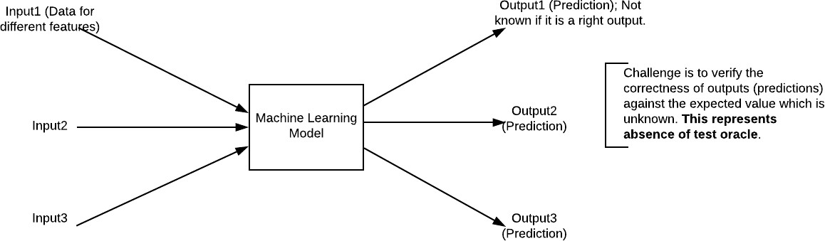

Unit Testing

Unit testing is usually conducted as part of a combined code and unit test phase of the software lifecycle, although it is not uncommon for coding and unit testing to be conducted as two distinct phases.

Test strategy and approach

Field testing will be performed manually and functional tests will be written in detail.

Test objectives

* All field entries must work properly.
* Pages must be activated from the identified link.
* The entry screen, messages and responses must not be delayed.

Features to be tested

* Verify that the entries are of the correct format
* No duplicate entries should be allowed
* All links should take the user to the correct page.

Integration Testing

Software integration testing is the incremental integration testing of two or more integrated software components on a single platform to produce failures caused by interface defects.

The task of the integration test is to check that components or software applications, e.g. components in a software system or – one step up – software applications at the company level – interact without error.

Test Results: All the test cases mentioned above passed successfully. No defects encountered.

Acceptance Testing

User Acceptance Testing is a critical phase of any project and requires significant participation by the end user. It also ensures that the system meets the functional requirements.

Test Results: All the test cases mentioned above passed successfully. No defects encountered.

**IMPLEMENTATION/SCREENSHORT:**

To enhance cyber supply chain security, several machine learning classifiers can be employed to detect and predict cyber threats. Here's how each of these classifiers might work within the context of your project:

### 1. \*\*Naive Bayes\*\*

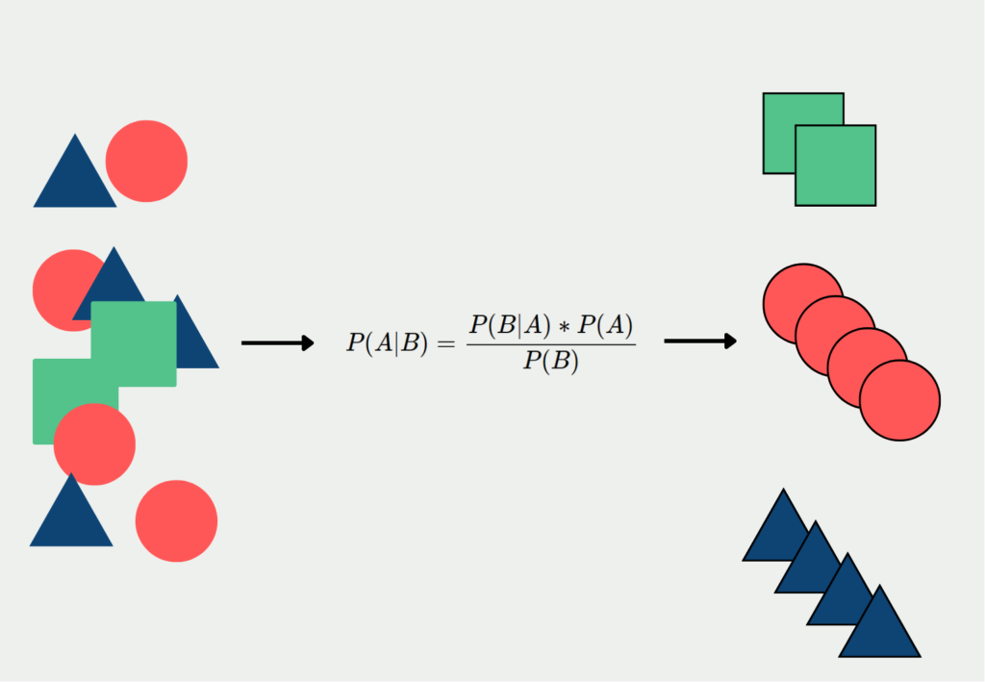

- \*\*How It Works:\*\* Naive Bayes is a probabilistic classifier based on Bayes' theorem. It assumes that the features used to classify an instance are conditionally independent given the class label.

- \*\*Application in the Project:\*\* Naive Bayes can be used to classify potential threats by analyzing patterns in historical data. For example, it can predict whether a particular communication within the supply chain is benign or malicious based on prior occurrences of similar patterns.

### 2. \*\*Support Vector Machine (SVM)\*\*

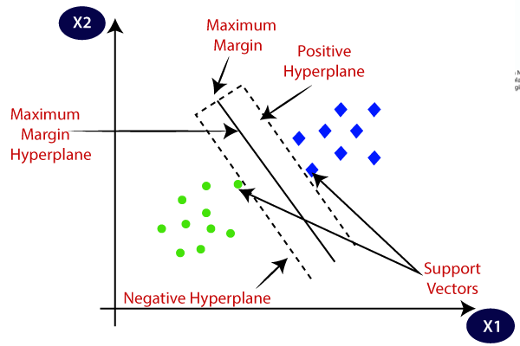

- \*\*How It Works:\*\* SVM is a supervised learning algorithm that finds the optimal hyperplane to separate data points into different classes. It works well with high-dimensional data and is effective for binary classification problems.

- \*\*Application in the Project:\*\* SVM can be used to detect anomalies in supply chain communications or transactions. By mapping data points into a high-dimensional space, SVM can distinguish between normal and suspicious activities, helping to identify potential cyber threats.

### 3. \*\*Logistic Regression\*\*

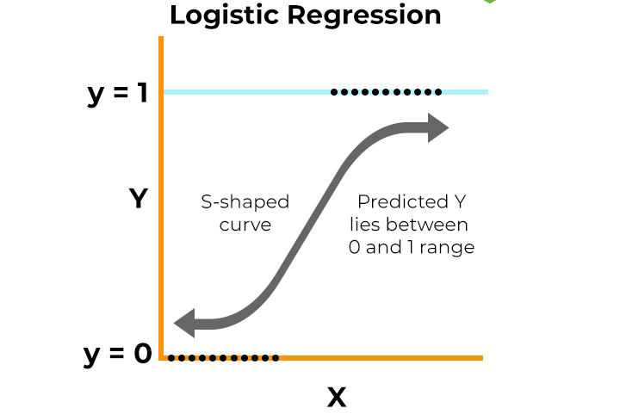

- \*\*How It Works:\*\* Logistic regression models the probability that a given input belongs to a certain class. It is particularly useful for binary classification tasks where the outcome is either a 0 or 1.

- \*\*Application in the Project:\*\* Logistic regression can be employed to predict the likelihood of a cyberattack occurring based on specific indicators or features within the supply chain data, such as unusual login times or unexpected file transfers.

### 4. \*\*Decision Tree Classifier\*\*

- \*\*How It Works:\*\* A decision tree classifier splits the data into subsets based on the value of input features, creating a tree-like model of decisions. It is easy to interpret and can handle both categorical and numerical data.

- \*\*Application in the Project:\*\* Decision trees can be used to classify different types of threats based on various attributes, such as the origin of a communication, the type of file being transferred, or the behavior of users within the supply chain.

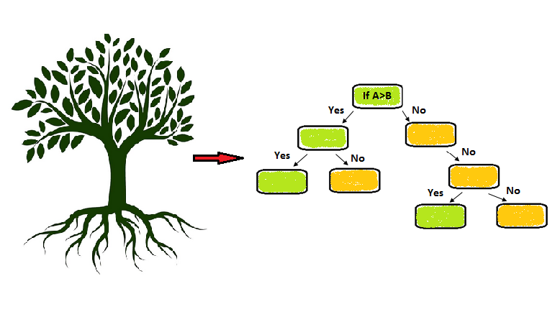

### 5. \*\*Stochastic Gradient Descent (SGD) Classifier\*\*



- \*\*How It Works:\*\* The SGD classifier is a linear model that uses stochastic gradient descent for optimization. It is efficient for large-scale datasets and can be applied to different loss functions like hinge loss (SVM) or log loss (logistic regression).

- \*\*Application in the Project:\*\* SGD can be used to quickly classify large volumes of data within the supply chain, such as network traffic or transaction logs, to identify potential threats in real-time.

### 6. \*\*K-Nearest Neighbors (KNN)\*\*

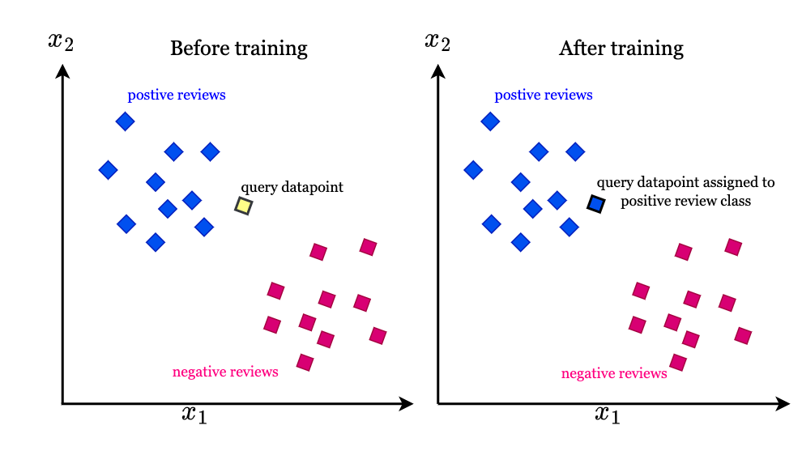

- \*\*How It Works:\*\* KNN is a non-parametric algorithm that classifies instances based on the majority class of the k-nearest neighbors in the feature space. It is simple and effective for small to medium-sized datasets.

- \*\*Application in the Project:\*\* KNN can be used to detect anomalies by comparing new data points with historical data. For instance, if a new transaction or communication is significantly different from its neighbors, it could be flagged as suspicious.

### 7. \*\*Random Forest Classifier\*\*

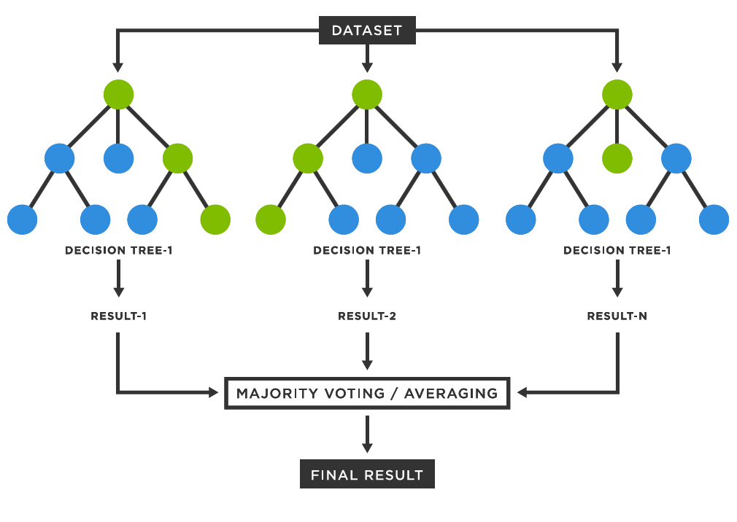

- \*\*How It Works:\*\* Random Forest is an ensemble learning method that combines multiple decision trees to improve classification accuracy and reduce overfitting. Each tree in the forest votes on the class label, and the majority vote is taken as the final prediction.

- \*\*Application in the Project:\*\* Random Forest can be used to identify complex patterns in supply chain data that might indicate a cyber threat. Its robustness to overfitting and ability to handle large datasets make it suitable for analyzing diverse and complex data sources within the supply chain.

### Implementation Steps:

1. \*\*Data Collection:\*\* Gather historical data on supply chain activities, including network logs, transactions, user behaviors, etc. This data will serve as the input features for training the models.

2. \*\*Feature Engineering:\*\* Select and engineer features that are indicative of cyber threats. These could include timestamps, IP addresses, file types, user roles, and other relevant attributes.

3. \*\*Model Training:\*\* Train each of the classifiers (Naive Bayes, SVM, Logistic Regression, etc.) on labeled data, where the outcomes (e.g., benign or malicious) are known.

4. \*\*Model Evaluation:\*\* Evaluate the performance of each model using metrics like accuracy, precision, recall, and F1-score. This will help determine which classifier is most effective for your specific use case.

5. \*\*Model Deployment:\*\* Deploy the best-performing models in your cyber supply chain security system. The models can be integrated into real-time monitoring systems to continuously classify new data and identify potential threats.

6. \*\*Continuous Improvement:\*\* Regularly update and retrain the models with new data to adapt to evolving threats and ensure the system remains effective over time.

By using these classifiers, the proposed system can enhance the detection and prediction of cyber threats within the supply chain, ultimately improving overall security.

CODING:

VIEWS.PY

from django.db.models import Count

from django.db.models import Q

from django.shortcuts import render, redirect, get\_object\_or\_404

import datetime

import openpyxl

import nltk

import re

import string

from nltk.corpus import stopwords

from sklearn.feature\_extraction.text import CountVectorizer

from nltk.stem.wordnet import WordNetLemmatizer

from sklearn.ensemble import RandomForestClassifier

import pandas as pd

from wordcloud import WordCloud, STOPWORDS

from sklearn.feature\_extraction.text import CountVectorizer

from sklearn.metrics import accuracy\_score, confusion\_matrix, classification\_report

from sklearn.metrics import accuracy\_score

from sklearn.metrics import f1\_score

from sklearn.tree import DecisionTreeClassifier

from sklearn.ensemble import VotingClassifier

# Create your views here.

from Remote\_User.models import ClientRegister\_Model,Cyber\_model,detection\_ratio,detection\_accuracy

def login(request):

if request.method == "POST" and 'submit1' in request.POST:

username = request.POST.get('username')

password = request.POST.get('password')

try:

enter = ClientRegister\_Model.objects.get(username=username,password=password)

request.session["userid"] = enter.id

return redirect('ViewYourProfile')

except:

pass

return render(request,'RUser/login.html')

def Add\_DataSet\_Details(request):

return render(request, 'RUser/Add\_DataSet\_Details.html', {"excel\_data": ''})

def Register1(request):

if request.method == "POST":

username = request.POST.get('username')

email = request.POST.get('email')

password = request.POST.get('password')

phoneno = request.POST.get('phoneno')

country = request.POST.get('country')

state = request.POST.get('state')

city = request.POST.get('city')

ClientRegister\_Model.objects.create(username=username, email=email, password=password, phoneno=phoneno,

country=country, state=state, city=city)

return render(request, 'RUser/Register1.html')

else:

return render(request,'RUser/Register1.html')

def ViewYourProfile(request):

userid = request.session['userid']

obj = ClientRegister\_Model.objects.get(id= userid)

return render(request,'RUser/ViewYourProfile.html',{'object':obj})

def Predict\_CyberThreat\_Type(request):

if request.method == "POST":

review = request.POST.get('keyword')

if request.method == "POST":

Name\_of\_Covered\_Entity= request.POST.get('Name\_of\_Covered\_Entity')

State= request.POST.get('State')

Individuals\_Affected= request.POST.get('Individuals\_Affected')

Date\_of\_Breach= request.POST.get('Date\_of\_Breach')

Location\_of\_Breached\_Information= request.POST.get('Location\_of\_Breached\_Information')

Date\_Posted\_or\_Updated= request.POST.get('Date\_Posted\_or\_Updated')

breach\_start= request.POST.get('breach\_start')

year= request.POST.get('year')

Source\_Ip= request.POST.get('Source\_Ip')

Destination\_Ip= request.POST.get('Destination\_Ip')

data = pd.read\_csv("Cyber\_Threat.csv")

# data.replace([np.inf, -np.inf], np.nan, inplace=True)

mapping = {'Theft': 0,

'Loss': 1,

'Disclosure': 2,

'Hacking': 3,

'Improper Disposal': 4

}

data['Label'] = data['Type\_of\_Breach'].map(mapping)

x = data['Name\_of\_Covered\_Entity']

y = data['Label']

# data.drop(['Type\_of\_Breach'],axis = 1, inplace = True)

cv = CountVectorizer()

print(x)

print(y)

labeled = 'labeled\_data.csv'

data.to\_csv(labeled, index=False)

data.to\_markdown

x = cv.fit\_transform(x)

models = []

from sklearn.model\_selection import train\_test\_split

X\_train, X\_test, y\_train, y\_test = train\_test\_split(x, y, test\_size=0.20)

X\_train.shape, X\_test.shape, y\_train.shape

print("Naive Bayes")

from sklearn.naive\_bayes import MultinomialNB

NB = MultinomialNB()

NB.fit(X\_train, y\_train)

predict\_nb = NB.predict(X\_test)

naivebayes = accuracy\_score(y\_test, predict\_nb) \* 100

print(naivebayes)

print(confusion\_matrix(y\_test, predict\_nb))

print(classification\_report(y\_test, predict\_nb))

models.append(('naive\_bayes', NB))

# SVM Model

print("SVM")

from sklearn import svm

lin\_clf = svm.LinearSVC()

lin\_clf.fit(X\_train, y\_train)

predict\_svm = lin\_clf.predict(X\_test)

svm\_acc = accuracy\_score(y\_test, predict\_svm) \* 100

print(svm\_acc)

print("CLASSIFICATION REPORT")

print(classification\_report(y\_test, predict\_svm))

print("CONFUSION MATRIX")

print(confusion\_matrix(y\_test, predict\_svm))

models.append(('svm', lin\_clf))

print("Logistic Regression")

from sklearn.linear\_model import LogisticRegression

reg = LogisticRegression(random\_state=0, solver='lbfgs').fit(X\_train, y\_train)

y\_pred = reg.predict(X\_test)

print("ACCURACY")

print(accuracy\_score(y\_test, y\_pred) \* 100)

print("CLASSIFICATION REPORT")

print(classification\_report(y\_test, y\_pred))

print("CONFUSION MATRIX")

print(confusion\_matrix(y\_test, y\_pred))

models.append(('logistic', reg))

print("Decision Tree Classifier")

dtc = DecisionTreeClassifier()

dtc.fit(X\_train, y\_train)

dtcpredict = dtc.predict(X\_test)

print("ACCURACY")

print(accuracy\_score(y\_test, dtcpredict) \* 100)

print("CLASSIFICATION REPORT")

print(classification\_report(y\_test, dtcpredict))

print("CONFUSION MATRIX")

print(confusion\_matrix(y\_test, dtcpredict))

models.append(('DecisionTreeClassifier', dtc))

print("SGD Classifier")

from sklearn.linear\_model import SGDClassifier

sgd\_clf = SGDClassifier(loss='hinge', penalty='l2', random\_state=0)

sgd\_clf.fit(X\_train, y\_train)

sgdpredict = sgd\_clf.predict(X\_test)

print("ACCURACY")

print(accuracy\_score(y\_test, sgdpredict) \* 100)

print("CLASSIFICATION REPORT")

print(classification\_report(y\_test, sgdpredict))

print("CONFUSION MATRIX")

print(confusion\_matrix(y\_test, sgdpredict))

models.append(('SGDClassifier', sgd\_clf))

print("KNeighborsClassifier")

from sklearn.neighbors import KNeighborsClassifier

kn = KNeighborsClassifier()

kn.fit(X\_train, y\_train)

knpredict = kn.predict(X\_test)

print("ACCURACY")

print(accuracy\_score(y\_test, knpredict) \* 100)

print("CLASSIFICATION REPORT")

print(classification\_report(y\_test, knpredict))

print("CONFUSION MATRIX")

print(confusion\_matrix(y\_test, knpredict))

models.append(('KNeighborsClassifier', kn))

classifier = VotingClassifier(models)

classifier.fit(X\_train, y\_train)

y\_pred = classifier.predict(X\_test)

data = [Name\_of\_Covered\_Entity]

vector1 = cv.transform(data).toarray()

predict\_text = classifier.predict(vector1)

pred = str(predict\_text).replace("[", "")

pred1 = pred.replace("]", "")

prediction = int(pred1)

if prediction == 0:

val = 'Theft'

elif prediction == 1:

val = 'Loss'

elif prediction == 2:

val = 'Disclosure'

elif prediction == 3:

val = 'Hacking'

elif prediction == 4:

val = 'Improper Disposal'

print(prediction)

print(val)

Cyber\_model.objects.create(Name\_of\_Covered\_Entity=Name\_of\_Covered\_Entity,

State=State,

Individuals\_Affected=Individuals\_Affected,

Date\_of\_Breach=Date\_of\_Breach,

Location\_of\_Breached\_Information=Location\_of\_Breached\_Information,

Date\_Posted\_or\_Updated=Date\_Posted\_or\_Updated,

breach\_start=breach\_start,

year=year,

Source\_Ip=Source\_Ip,

Destination\_Ip=Destination\_Ip,

Prediction=val)

return render(request, 'RUser/Predict\_CyberThreat\_Type.html',{'objs': val})

return render(request, 'RUser/Predict\_CyberThreat\_Type.html')

VIEWS.PY

from django.db.models import Count, Avg

from django.shortcuts import render, redirect

from django.db.models import Count

from django.db.models import Q

import datetime

import xlwt

from django.http import HttpResponse

import numpy as np

import nltk

import re

import string

from nltk.corpus import stopwords

from sklearn.feature\_extraction.text import CountVectorizer

from nltk.stem.wordnet import WordNetLemmatizer

import pandas as pd

from wordcloud import WordCloud, STOPWORDS

from sklearn.feature\_extraction.text import CountVectorizer

from sklearn.metrics import accuracy\_score, confusion\_matrix, classification\_report

from sklearn.metrics import accuracy\_score

from sklearn.metrics import f1\_score

from sklearn.tree import DecisionTreeClassifier

from sklearn.ensemble import VotingClassifier

from sklearn.ensemble import RandomForestClassifier

# Create your views here.

from Remote\_User.models import ClientRegister\_Model,Cyber\_model,detection\_ratio,detection\_accuracy

def serviceproviderlogin(request):

if request.method == "POST":

admin = request.POST.get('username')

password = request.POST.get('password')

if admin == "Admin" and password =="Admin":

detection\_accuracy.objects.all().delete()

return redirect('View\_Remote\_Users')

return render(request,'SProvider/serviceproviderlogin.html')

def View\_CyberThreat\_Type\_Ratio(request):

detection\_ratio.objects.all().delete()

ratio = ""

kword = 'Theft'

print(kword)

obj = Cyber\_model.objects.all().filter(Q(Prediction=kword))

obj1 = Cyber\_model.objects.all()

count = obj.count();

count1 = obj1.count();

ratio = (count / count1) \* 100

if ratio != 0:

detection\_ratio.objects.create(names=kword, ratio=ratio)

ratio1 = ""

kword1 = 'Loss'

print(kword1)

obj1 = Cyber\_model.objects.all().filter(Q(Prediction=kword1))

obj11 = Cyber\_model.objects.all()

count1 = obj1.count();

count11 = obj11.count();

ratio1 = (count1 / count11) \* 100

if ratio1 != 0:

detection\_ratio.objects.create(names=kword1, ratio=ratio1)

ratio12 = ""

kword12 = 'Disclosure'

print(kword12)

obj12 = Cyber\_model.objects.all().filter(Q(Prediction=kword12))

obj112 = Cyber\_model.objects.all()

count12 = obj12.count();

count112 = obj112.count();

ratio12 = (count12 / count112) \* 100

if ratio12 != 0:

detection\_ratio.objects.create(names=kword12, ratio=ratio12)

ratio123 = ""

kword123 = 'Hacking'

print(kword123)

obj123 = Cyber\_model.objects.all().filter(Q(Prediction=kword123))

obj1123 = Cyber\_model.objects.all()

count123 = obj123.count();

count1123 = obj1123.count();

ratio123 = (count123 / count1123) \* 100

if ratio123 != 0:

detection\_ratio.objects.create(names=kword123, ratio=ratio123)

ratio123a = ""

kword123a = 'Improper Disposal'

print(kword123a)

obj123a = Cyber\_model.objects.all().filter(Q(Prediction=kword123a))

obj1123a = Cyber\_model.objects.all()

count123a = obj123a.count();

count1123a = obj1123a.count();

ratio123a = (count123a / count1123a) \* 100

if ratio123a != 0:

detection\_ratio.objects.create(names=kword123a, ratio=ratio123a)

obj = detection\_ratio.objects.all()

return render(request, 'SProvider/View\_CyberThreat\_Type\_Ratio.html', {'objs': obj})

def View\_Remote\_Users(request):

obj=ClientRegister\_Model.objects.all()

return render(request,'SProvider/View\_Remote\_Users.html',{'objects':obj})

def ViewTrendings(request):

topic = Cyber\_model.objects.values('topics').annotate(dcount=Count('topics')).order\_by('-dcount')

return render(request,'SProvider/ViewTrendings.html',{'objects':topic})

def charts(request,chart\_type):

chart1 = detection\_ratio.objects.values('names').annotate(dcount=Avg('ratio'))

return render(request,"SProvider/charts.html", {'form':chart1, 'chart\_type':chart\_type})

def charts1(request,chart\_type):

chart1 = detection\_accuracy.objects.values('names').annotate(dcount=Avg('ratio'))

return render(request,"SProvider/charts1.html", {'form':chart1, 'chart\_type':chart\_type})

def View\_Prediction\_Of\_CyberThreat\_Type(request):

obj =Cyber\_model.objects.all()

return render(request, 'SProvider/View\_Prediction\_Of\_CyberThreat\_Type.html', {'list\_objects': obj})

def likeschart(request,like\_chart):

charts =detection\_accuracy.objects.values('names').annotate(dcount=Avg('ratio'))

return render(request,"SProvider/likeschart.html", {'form':charts, 'like\_chart':like\_chart})

def Download\_Trained\_DataSets(request):

response = HttpResponse(content\_type='application/ms-excel')

# decide file name

response['Content-Disposition'] = 'attachment; filename="Predicted\_Data.xls"'

# creating workbook

wb = xlwt.Workbook(encoding='utf-8')

# adding sheet

ws = wb.add\_sheet("sheet1")

# Sheet header, first row

row\_num = 0

font\_style = xlwt.XFStyle()

# headers are bold

font\_style.font.bold = True

# writer = csv.writer(response)

obj = Cyber\_model.objects.all()

data = obj # dummy method to fetch data.

for my\_row in data:

row\_num = row\_num + 1

ws.write(row\_num, 0, my\_row.Name\_of\_Covered\_Entity, font\_style)

ws.write(row\_num, 1, my\_row.State, font\_style)

ws.write(row\_num, 2, my\_row.Individuals\_Affected, font\_style)

ws.write(row\_num, 3, my\_row.Date\_of\_Breach, font\_style)

ws.write(row\_num, 4, my\_row.Location\_of\_Breached\_Information, font\_style)

ws.write(row\_num, 5, my\_row.Date\_Posted\_or\_Updated, font\_style)

ws.write(row\_num, 6, my\_row.breach\_start, font\_style)

ws.write(row\_num, 7, my\_row.year, font\_style)

ws.write(row\_num, 8, my\_row.Source\_Ip, font\_style)

ws.write(row\_num, 9, my\_row.Destination\_Ip, font\_style)

ws.write(row\_num, 10, my\_row.Prediction, font\_style)

wb.save(response)

return response

def train\_model(request):

detection\_accuracy.objects.all().delete()

data = pd.read\_csv("Cyber\_Threat.csv")

# data.replace([np.inf, -np.inf], np.nan, inplace=True)

mapping = {'Theft': 0,

'Loss': 1,

'Disclosure': 2,

'Hacking': 3,

'Improper Disposal': 4

}

data['Label'] = data['Type\_of\_Breach'].map(mapping)

x = data['Name\_of\_Covered\_Entity']

y = data['Label']

# data.drop(['Type\_of\_Breach'],axis = 1, inplace = True)

cv = CountVectorizer()

print(x)

print(y)

labeled = 'labeled\_data.csv'

data.to\_csv(labeled, index=False)

data.to\_markdown

x = cv.fit\_transform(x)

models = []

from sklearn.model\_selection import train\_test\_split

X\_train, X\_test, y\_train, y\_test = train\_test\_split(x, y, test\_size=0.20)

X\_train.shape, X\_test.shape, y\_train.shape

print("Naive Bayes")

from sklearn.naive\_bayes import MultinomialNB

NB = MultinomialNB()

NB.fit(X\_train, y\_train)

predict\_nb = NB.predict(X\_test)

naivebayes = accuracy\_score(y\_test, predict\_nb) \* 100

print(naivebayes)

print(confusion\_matrix(y\_test, predict\_nb))

print(classification\_report(y\_test, predict\_nb))

models.append(('naive\_bayes', NB))

detection\_accuracy.objects.create(names="Naive Bayes", ratio=naivebayes)

# SVM Model

print("SVM")

from sklearn import svm

lin\_clf = svm.LinearSVC()

lin\_clf.fit(X\_train, y\_train)

predict\_svm = lin\_clf.predict(X\_test)

svm\_acc = accuracy\_score(y\_test, predict\_svm) \* 100

print(svm\_acc)

print("CLASSIFICATION REPORT")

print(classification\_report(y\_test, predict\_svm))

print("CONFUSION MATRIX")

print(confusion\_matrix(y\_test, predict\_svm))

models.append(('svm', lin\_clf))

detection\_accuracy.objects.create(names="SVM", ratio=svm\_acc)

print("Logistic Regression")

from sklearn.linear\_model import LogisticRegression

reg = LogisticRegression(random\_state=0, solver='lbfgs').fit(X\_train, y\_train)

y\_pred = reg.predict(X\_test)

print("ACCURACY")

print(accuracy\_score(y\_test, y\_pred) \* 100)

print("CLASSIFICATION REPORT")

print(classification\_report(y\_test, y\_pred))

print("CONFUSION MATRIX")

print(confusion\_matrix(y\_test, y\_pred))

models.append(('logistic', reg))

detection\_accuracy.objects.create(names="Logistic Regression", ratio=accuracy\_score(y\_test, y\_pred) \* 100)

print("Decision Tree Classifier")

dtc = DecisionTreeClassifier()

dtc.fit(X\_train, y\_train)

dtcpredict = dtc.predict(X\_test)

print("ACCURACY")

print(accuracy\_score(y\_test, dtcpredict) \* 100)

print("CLASSIFICATION REPORT")

print(classification\_report(y\_test, dtcpredict))

print("CONFUSION MATRIX")

print(confusion\_matrix(y\_test, dtcpredict))

models.append(('DecisionTreeClassifier', dtc))

detection\_accuracy.objects.create(names="Decision Tree Classifier", ratio=accuracy\_score(y\_test, dtcpredict) \* 100)

print("SGD Classifier")

from sklearn.linear\_model import SGDClassifier

sgd\_clf = SGDClassifier(loss='hinge', penalty='l2', random\_state=0)

sgd\_clf.fit(X\_train, y\_train)

sgdpredict = sgd\_clf.predict(X\_test)

print("ACCURACY")

print(accuracy\_score(y\_test, sgdpredict) \* 100)

print("CLASSIFICATION REPORT")

print(classification\_report(y\_test, sgdpredict))

print("CONFUSION MATRIX")

print(confusion\_matrix(y\_test, sgdpredict))

models.append(('SGDClassifier', sgd\_clf))

detection\_accuracy.objects.create(names="SGD Classifier", ratio=accuracy\_score(y\_test, sgdpredict) \* 100)

print("KNeighborsClassifier")

from sklearn.neighbors import KNeighborsClassifier

kn = KNeighborsClassifier()

kn.fit(X\_train, y\_train)

knpredict = kn.predict(X\_test)

print("ACCURACY")

print(accuracy\_score(y\_test, knpredict) \* 100)

print("CLASSIFICATION REPORT")

print(classification\_report(y\_test, knpredict))

print("CONFUSION MATRIX")

print(confusion\_matrix(y\_test, knpredict))

models.append(('KNeighborsClassifier', kn))

detection\_accuracy.objects.create(names="KNeighborsClassifier", ratio=accuracy\_score(y\_test, knpredict) \* 100)

print("Random Forest Classifier")

rf = RandomForestClassifier()

rf.fit(X\_train, y\_train)

pred\_rfc = rf.predict(X\_test)

print("ACCURACY")

print(accuracy\_score(y\_test, pred\_rfc) \* 100)

print("CLASSIFICATION REPORT")

print(classification\_report(y\_test, pred\_rfc))

print("CONFUSION MATRIX")

print(confusion\_matrix(y\_test, pred\_rfc))

detection\_accuracy.objects.create(names="Random Forest Classifier", ratio=accuracy\_score(y\_test, pred\_rfc) \* 100)

labeled = 'labeled\_data.csv'

data.to\_csv(labeled, index=False)

data.to\_markdown

obj = detection\_accuracy.objects.all()

return render(request,'SProvider/train\_model.html', {'objs': obj})

SCREENSHORT

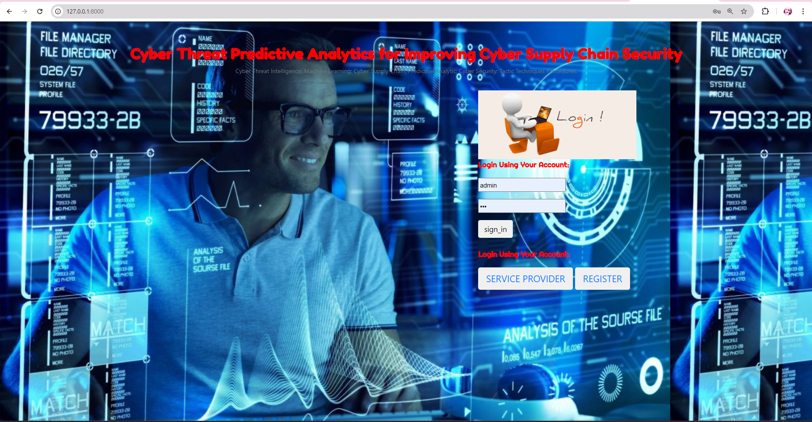

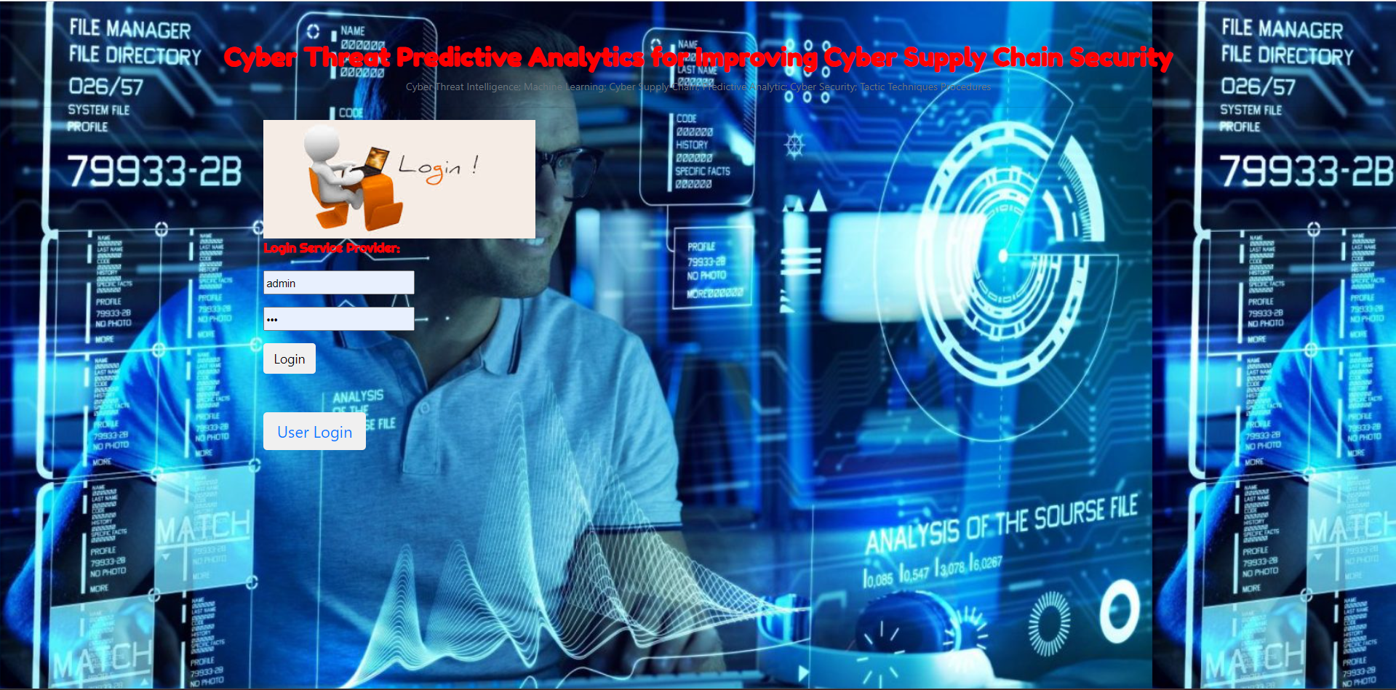

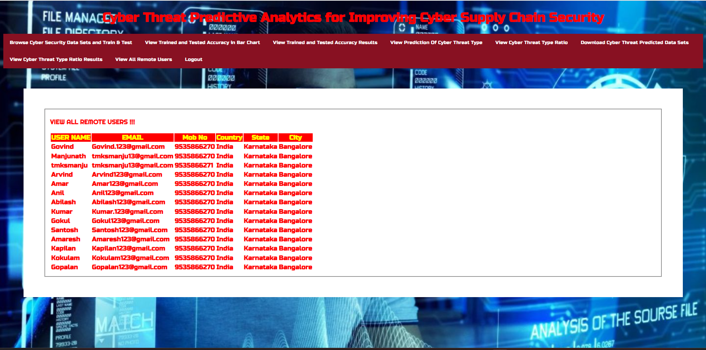

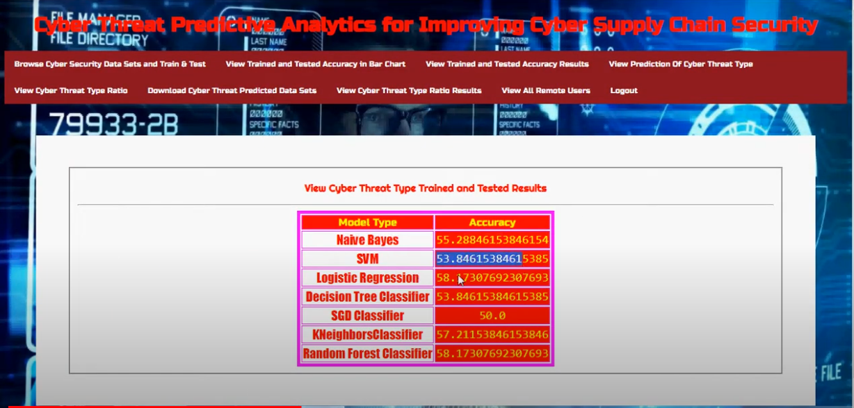

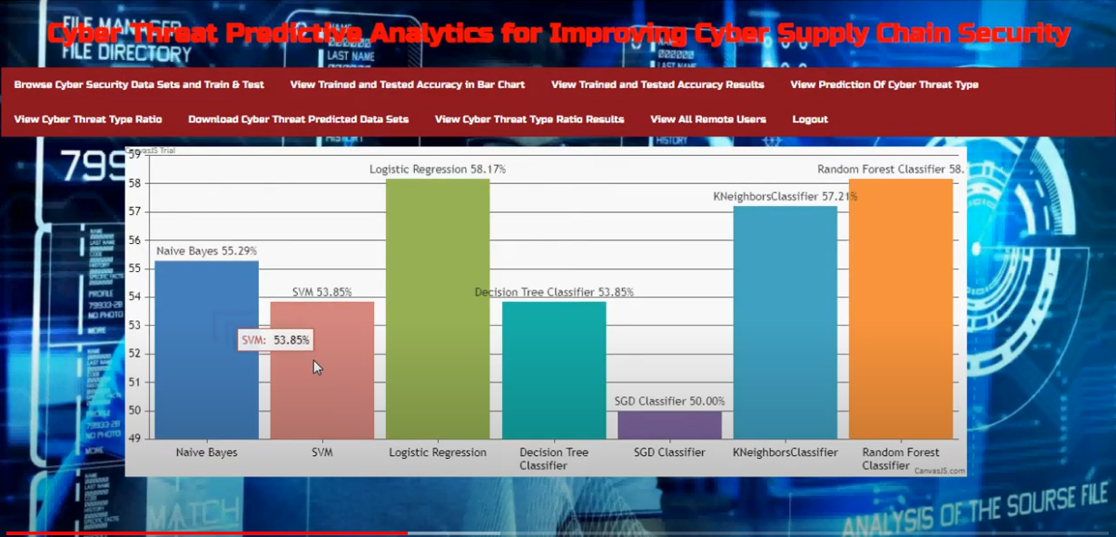

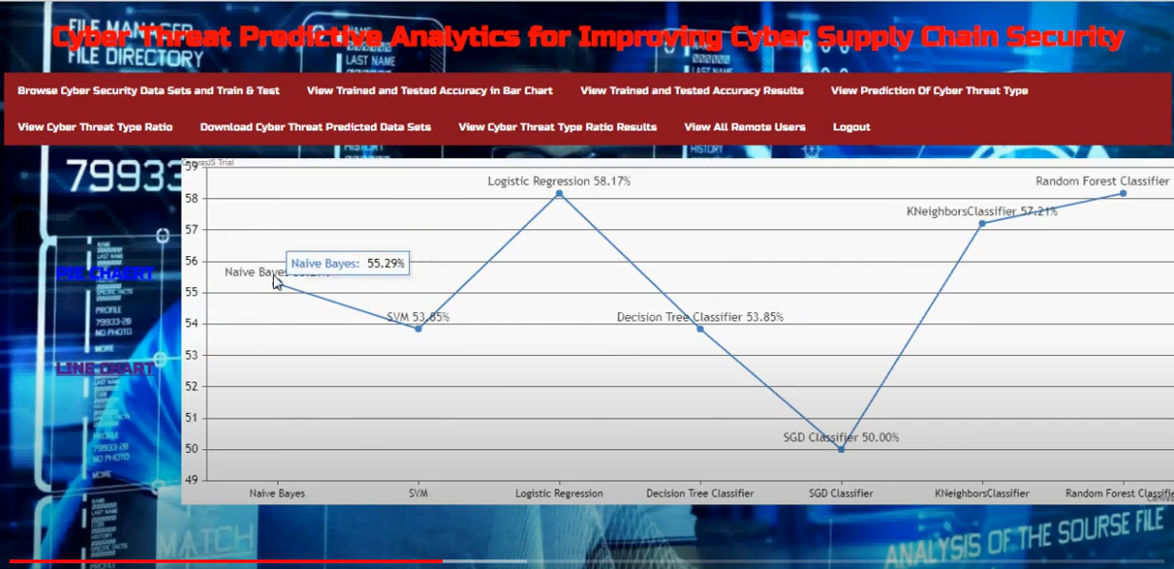

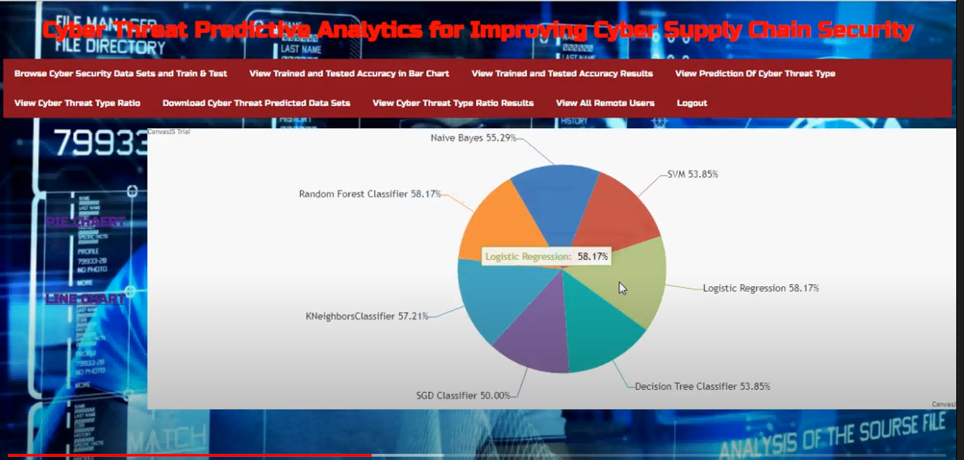

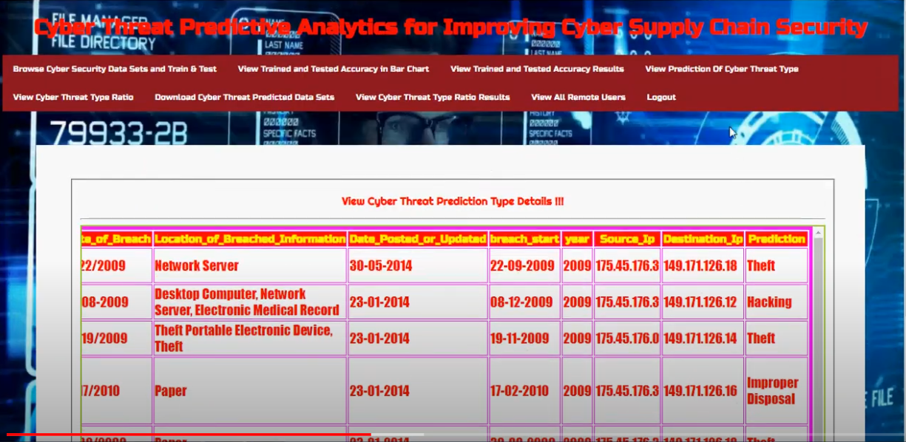

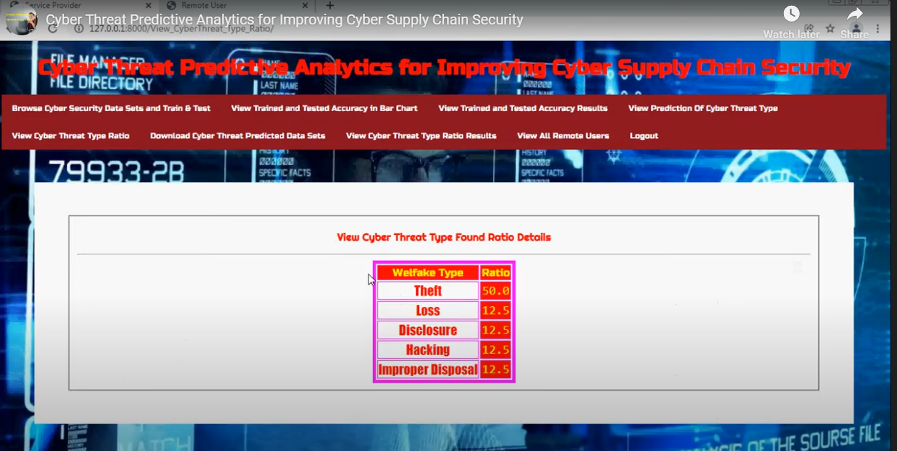

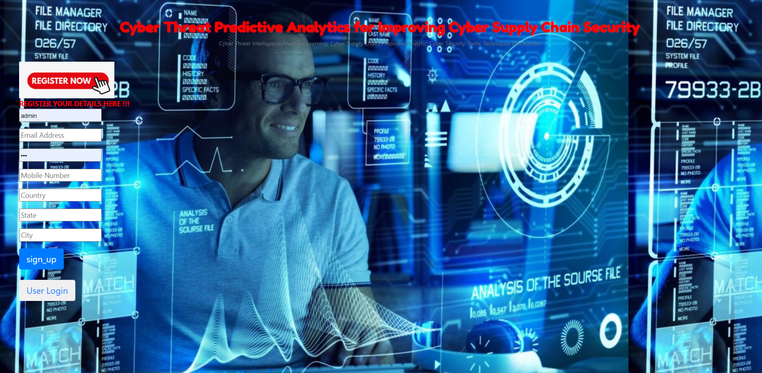





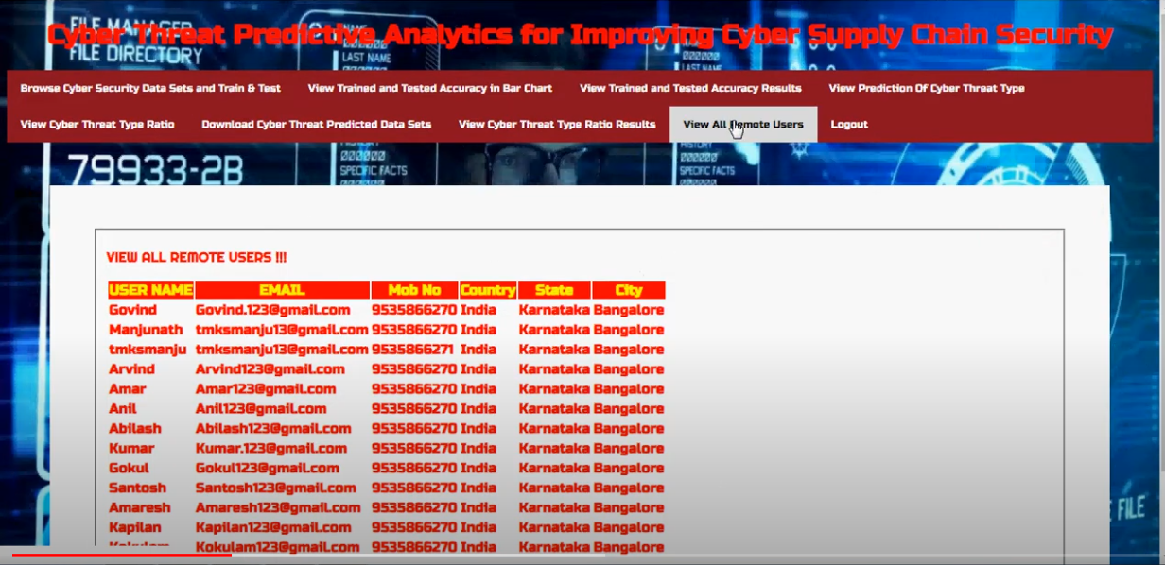

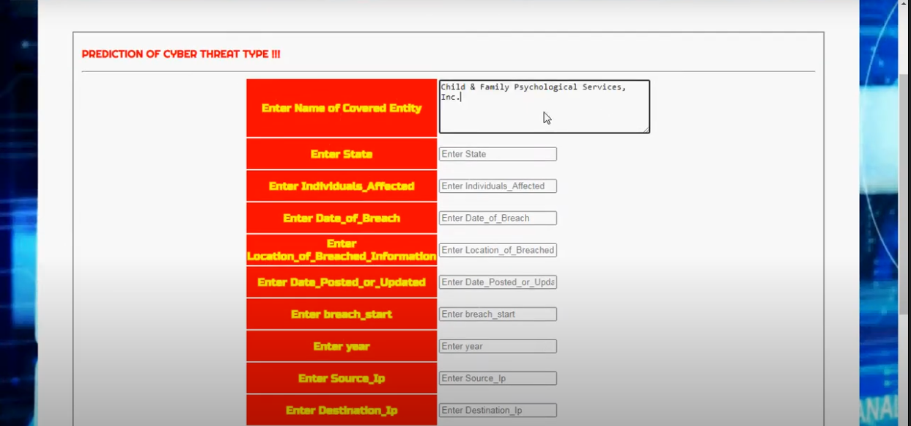

Conclsion

In conclusion, enhancing cyber supply chain security through the integration of advanced machine learning classifiers offers a proactive and comprehensive approach to mitigating the ever-evolving threats that organizations face today. By employing models such as Naive Bayes, SVM, Logistic Regression, Decision Trees, SGD, KNN, and Random Forest, the system can effectively identify, predict, and respond to potential cyber threats before they can cause significant damage.

These classifiers not only improve the accuracy of threat detection but also enable real-time monitoring and rapid response, thereby reducing the risk of disruptions in critical supply chain operations. The implementation of such a system ensures that organizations are better equipped to safeguard their assets, maintain business continuity, and adapt to new challenges in the cybersecurity landscape. Ultimately, this integrated, intelligence-driven approach represents a significant advancement in the pursuit of robust cyber supply chain security.

Futurework

### Future Work

1. \*\*Integration of Advanced Threat Intelligence:\*\* Future work should focus on integrating more sophisticated threat intelligence sources into the system. This includes leveraging global threat databases, real-time threat feeds, and collaboration with cybersecurity organizations to enhance the system’s ability to detect and respond to emerging threats.

2. \*\*Adaptive Learning Models:\*\* Developing adaptive learning models that can continuously evolve with new threat patterns and attack vectors will be crucial. Implementing techniques such as reinforcement learning or meta-learning could allow the system to dynamically adjust its detection algorithms based on new data and attack trends.

3. \*\*Scalability and Efficiency:\*\* Improving the scalability of the system to handle large-scale, high-velocity data streams from extensive supply chain networks will be essential. This includes optimizing the performance of machine learning models and integrating efficient data processing pipelines to manage the increasing volume and complexity of supply chain data.

4. \*\*Enhanced Privacy and Security Measures:\*\* Future research should also address the privacy and security implications of handling sensitive supply chain data. Implementing privacy-preserving techniques, such as data anonymization and encryption, will be important to protect organizational and customer information while maintaining effective threat detection.

5. \*\*Interoperability and Standardization:\*\* Developing standardized frameworks and protocols for integrating various security tools and systems will improve interoperability. This will facilitate seamless communication between different components of the security infrastructure and enable more cohesive and effective threat management.

6. \*\*User and Behavior Analytics:\*\* Incorporating advanced user and behavior analytics to better understand normal and anomalous behaviors within the supply chain. This could involve analyzing user interactions, transaction patterns, and communication flows to identify subtle indicators of potential threats.

7. \*\*Collaborative Threat Intelligence Sharing:\*\* Promoting collaborative efforts and information sharing among organizations, industry groups, and governmental bodies will enhance collective threat awareness. This approach will help in building more comprehensive threat profiles and improving overall cybersecurity resilience.

8. \*\*Real-Time Response and Automation:\*\* Expanding the system’s capabilities for real-time automated responses to detected threats. This includes developing automated workflows for threat mitigation, incident handling, and recovery processes to minimize manual intervention and improve response times.

By focusing on these areas, future work can further enhance the effectiveness and adaptability of cyber supply chain security systems, ensuring they remain resilient against evolving cyber threats and capable of protecting critical infrastructure.

REFREFRENCES

1. National Cyber Security Centre. (2018). Example of Supply Chain Attacks. 2. A. Yeboah-Ofori and S. Islam, ‘‘Cyber security threat modelling for supply chain organizational environments,’’ MDPI. Future Internet, vol. 11, no. 3, p. 63, Mar. 2019. 3. B. Woods and A. Bochman, ‘‘Supply chain in the software era,’’ in Scowcroft Center for Strategic and Security. Washington, DC, USA: Atlantic Council, May 2018. 4. Exploring the Opportunities and Limitations of Current Threat Intelligence Platforms, Version 1, ENISA, Dec. 2017. 5. C. Doerr, TU Delft CTI Labs. (2018). Cyber Threat Intelligences Standards—A High Level Overview. 6. Research Prediction. (2019). Microsoft Malware Prediction. 7. A.Yeboah-Ofori and F. Katsriku, ‘‘Cybercrime and risks for cyber physical systems,’’ Int. J. Cyber-Secur. Digit. Forensics, vol. 8, no. 1, pp. 43–57, 2019. 8. CAPEC-437, Supply Chain. (Oct. 2018). Common Attack Pattern Enumeration and Classification: Domain of Attack. 9. Open Web Application Security Project (OWASP). (2017). The Ten Most Critical Application Security Risks, Creative Commons Attribution-Share Alike 4.0 International License. 10. US-Cert. (2020). Building Security in Software & Supply Chain Assurance